Figure-1. Seasonal accumulation of rainfall, 2019 and fraction of heavy rainfall contributed to seasonal accumulation over west coast region.

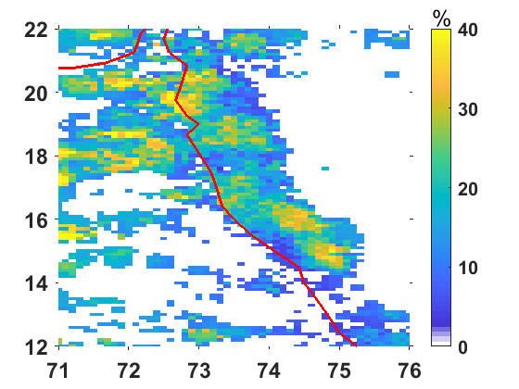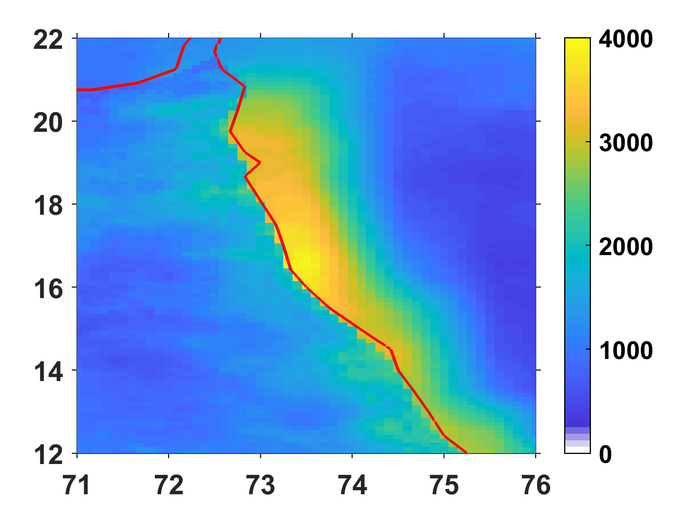



Figure-2. Diurnal variability of extreme rainfall events as observed by MESONET rain gauge network, Mumbai region. The box statistics represents the distribution of hourly rain fall magnitude. The red coloured line indicates the occurrence of number of mini cloud bursts over Mumbai region.

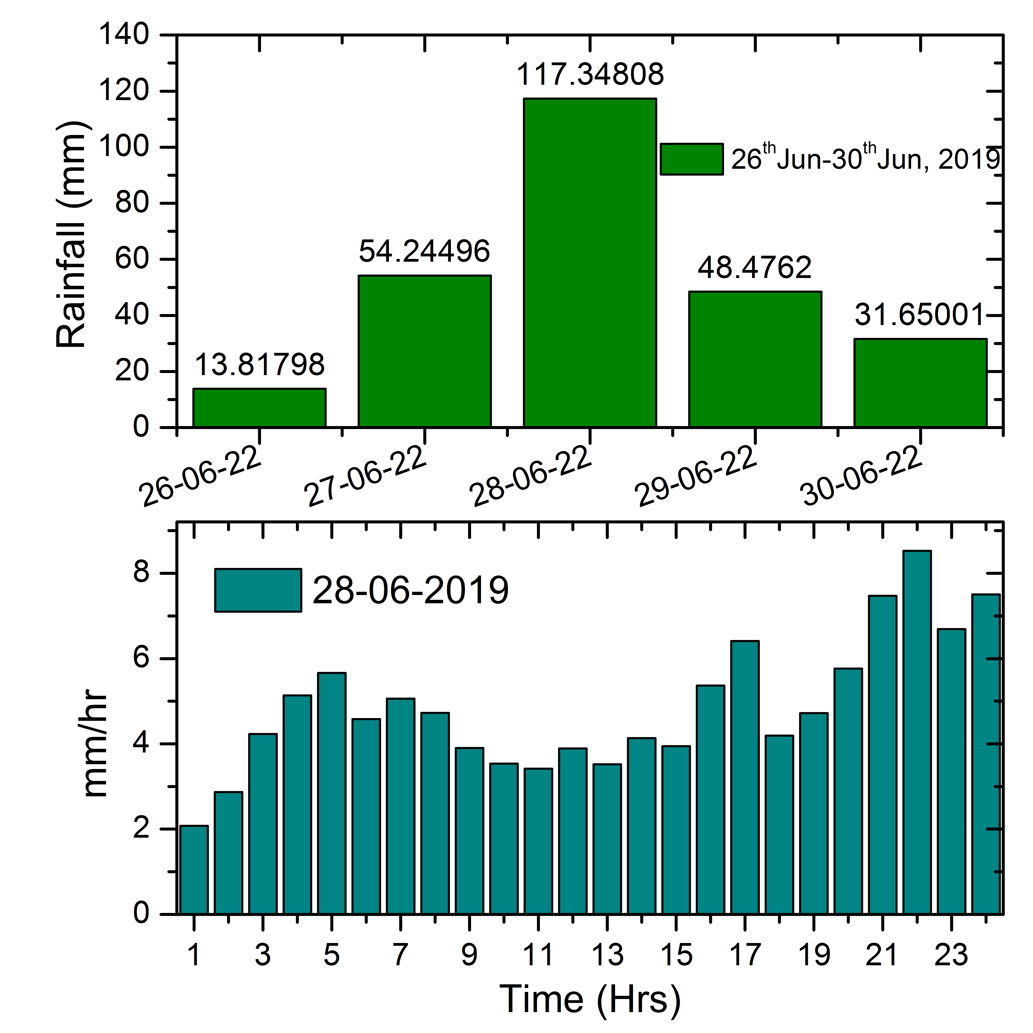

Figure-3. Areal average rainfall distribution on different temporal scale. Figure 3a represents daily average rainfall variability during 26th June to 30th June, 2019 over study region. Figure 3b shows the sub daily scale variability of rainfall on a extreme event day (28-06-2019).

Table-1.

|  |  |  |  |
| --- | --- | --- | --- |
| **List of events** |  |  |  |
| 22-26-07-2010 | 21-25-07-2013 | 18-22-08-2017 | 01-05-08-2019 |
| 03-07-06-2011 | 14-18-09-2016 | 17-21-09-2017 | 03-07-08-2020 |
| 01-05-09-2012 | 15-19-07-2017 | 29-06-03-07-2019 |  |

Figure-4. Seasonal distribution of heavy rainfall events during last decade (2010-2020).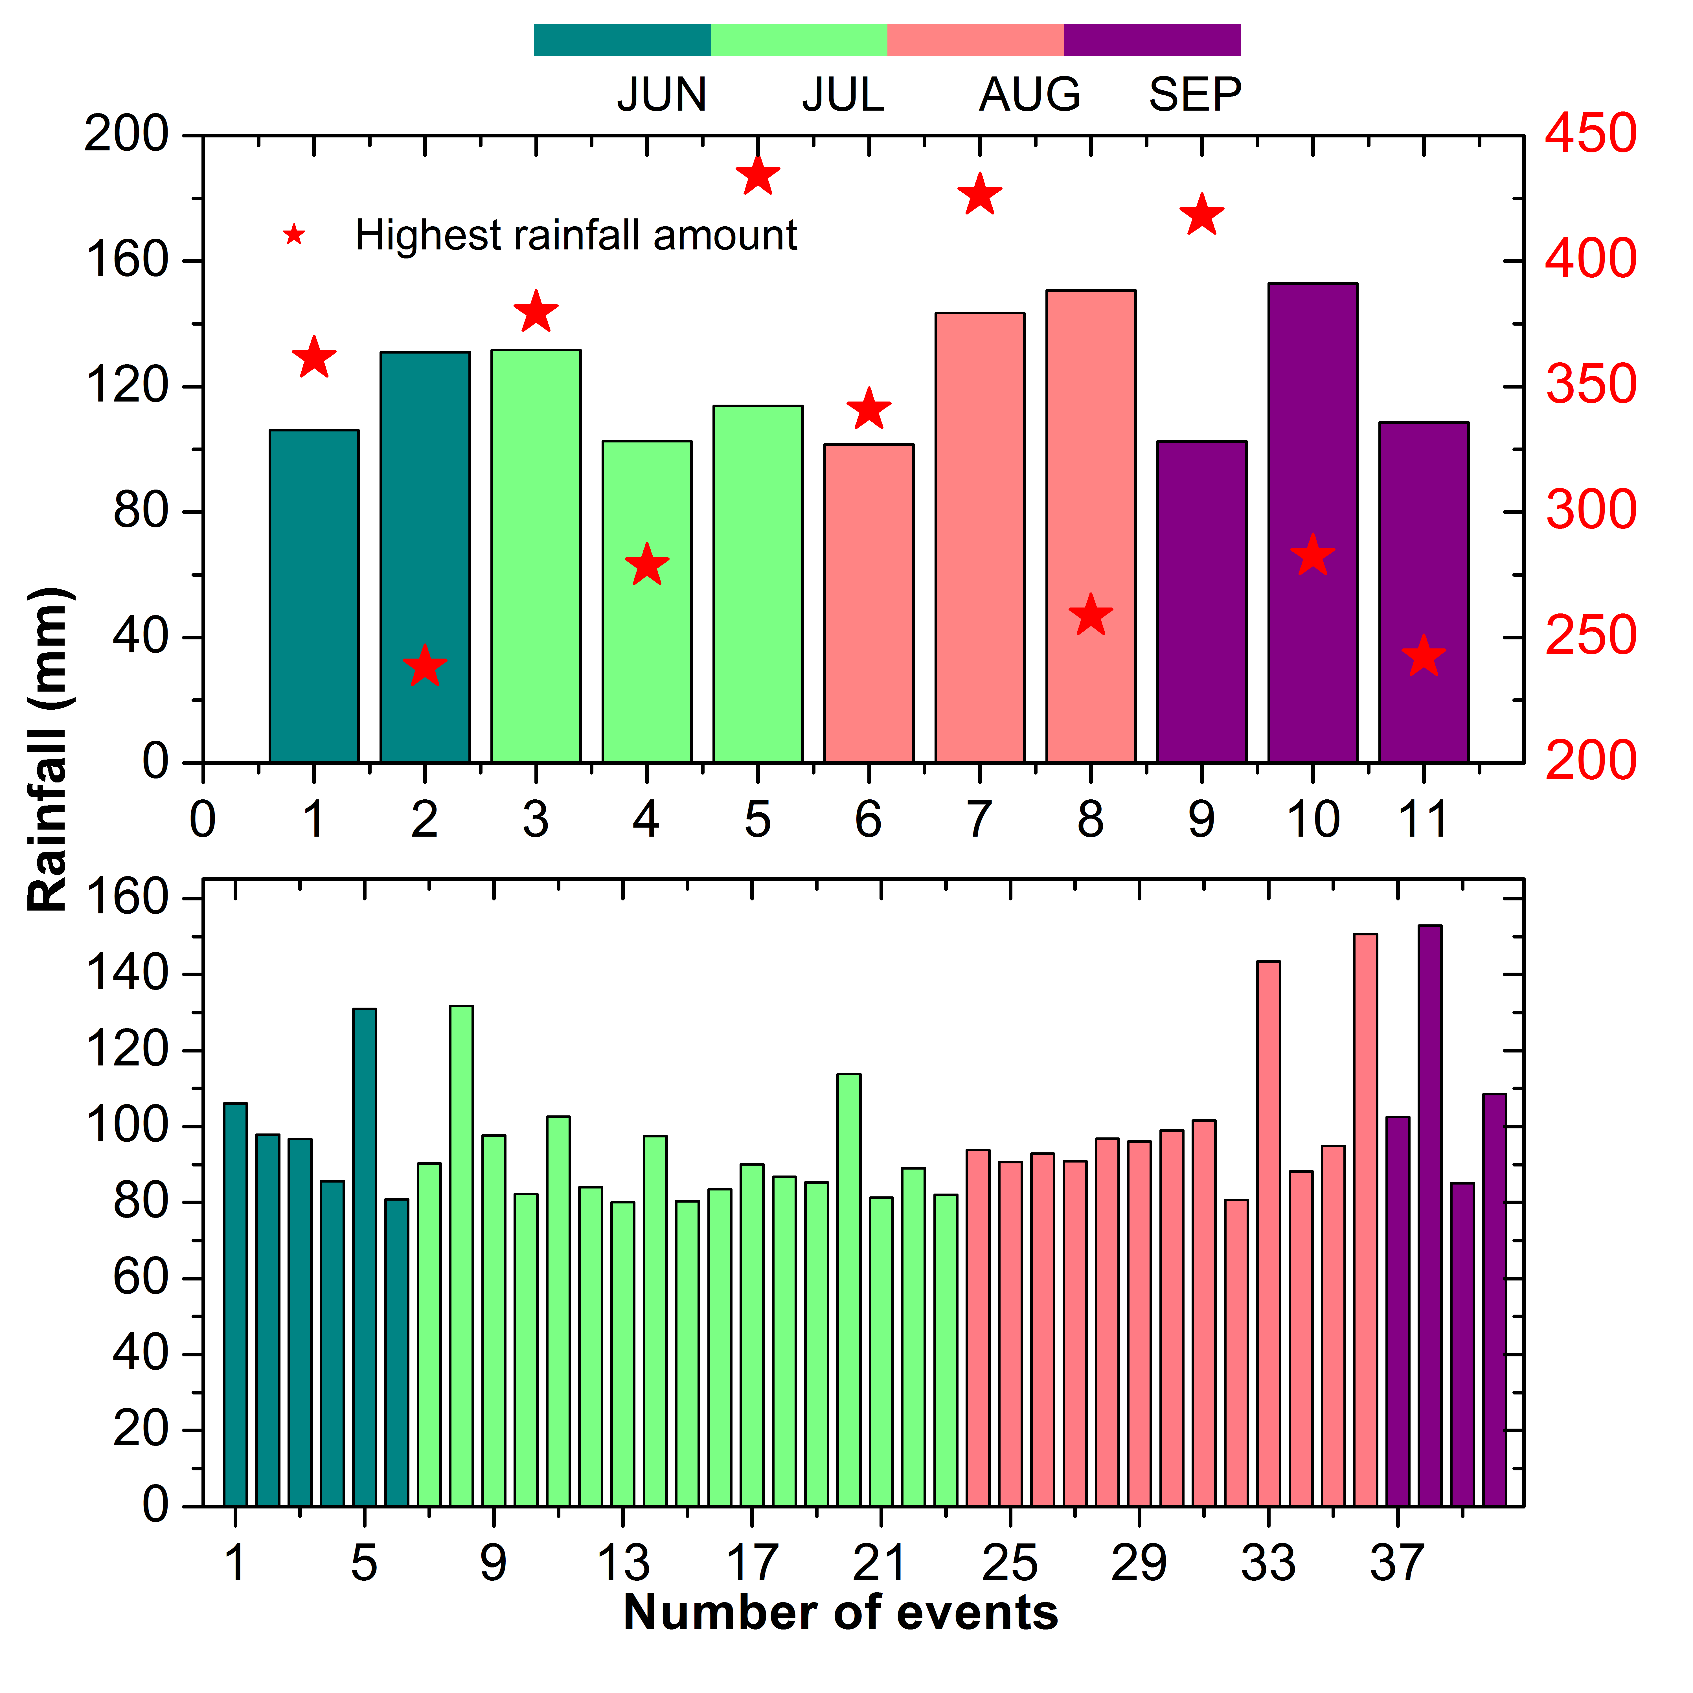

Figure 5. Spatial pattern of various attributes possibly associated with EREs sub scale variability.

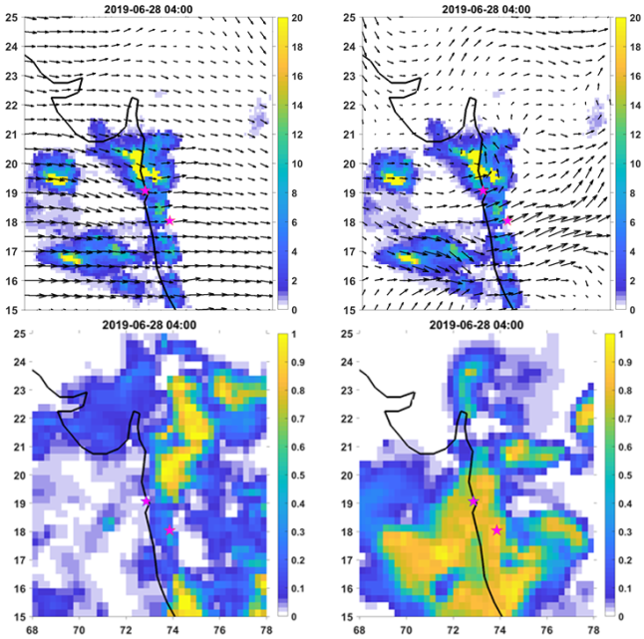

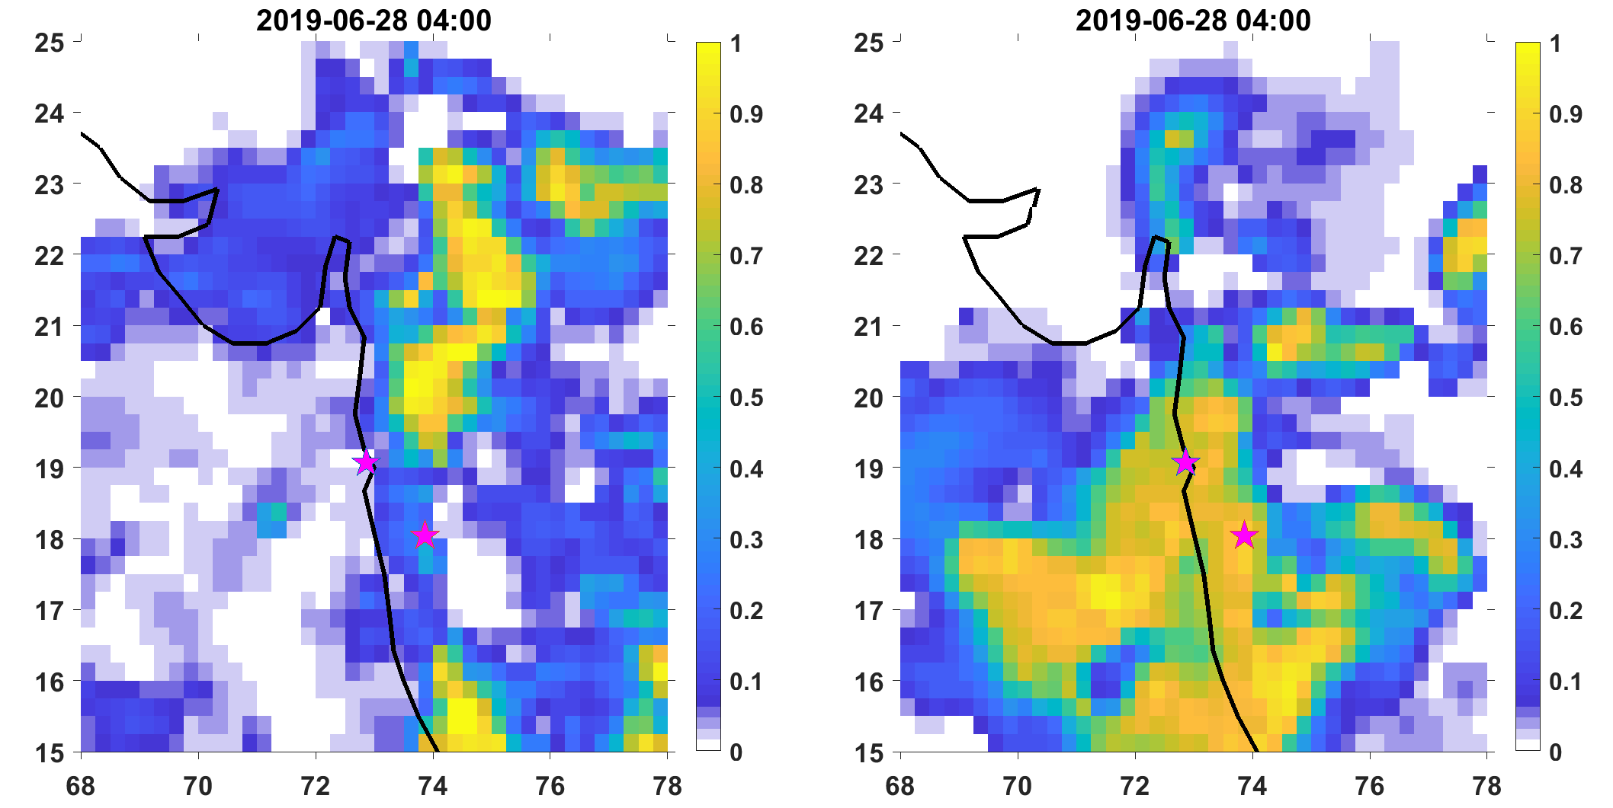

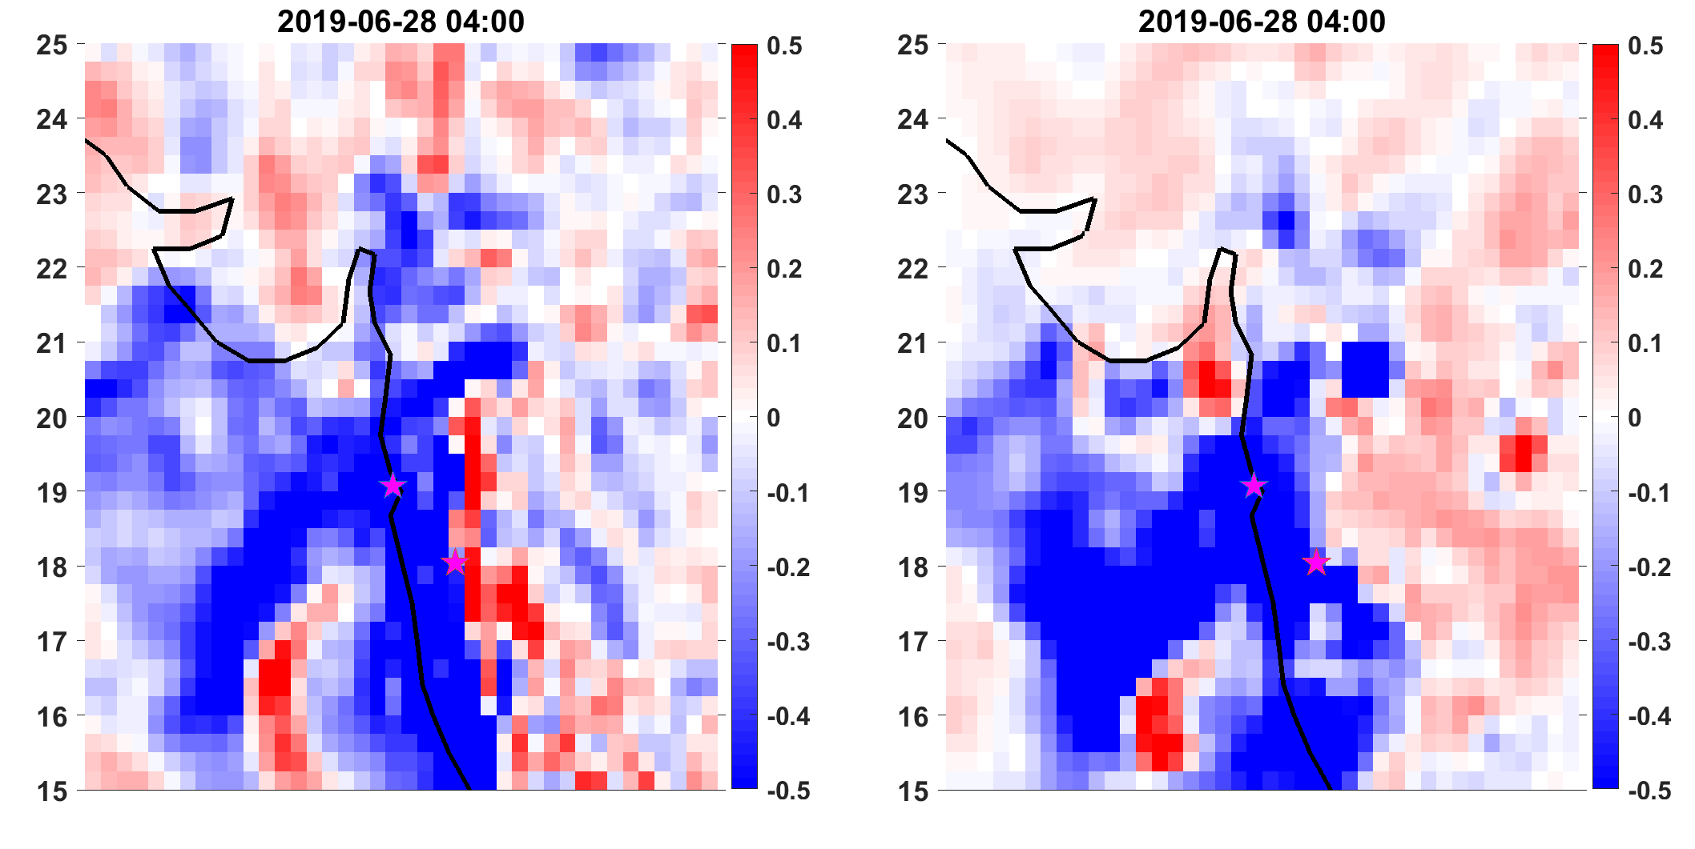

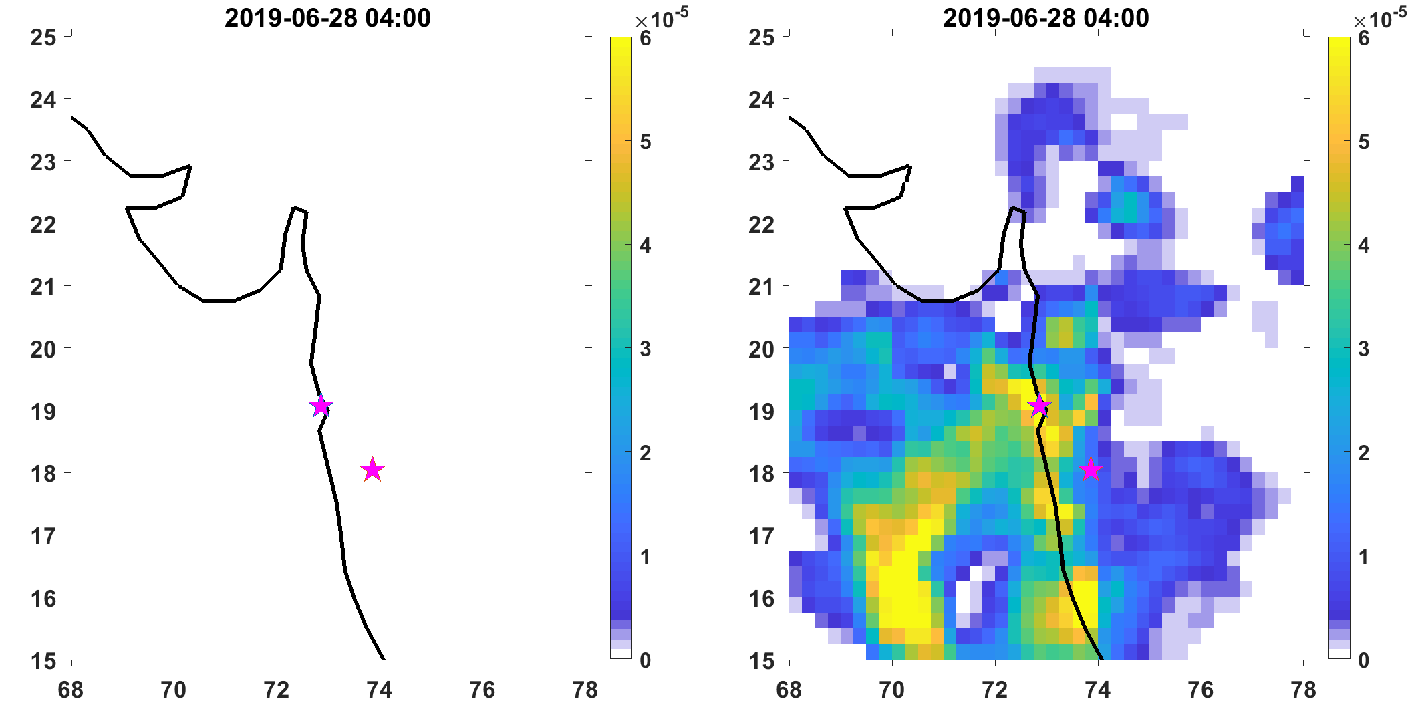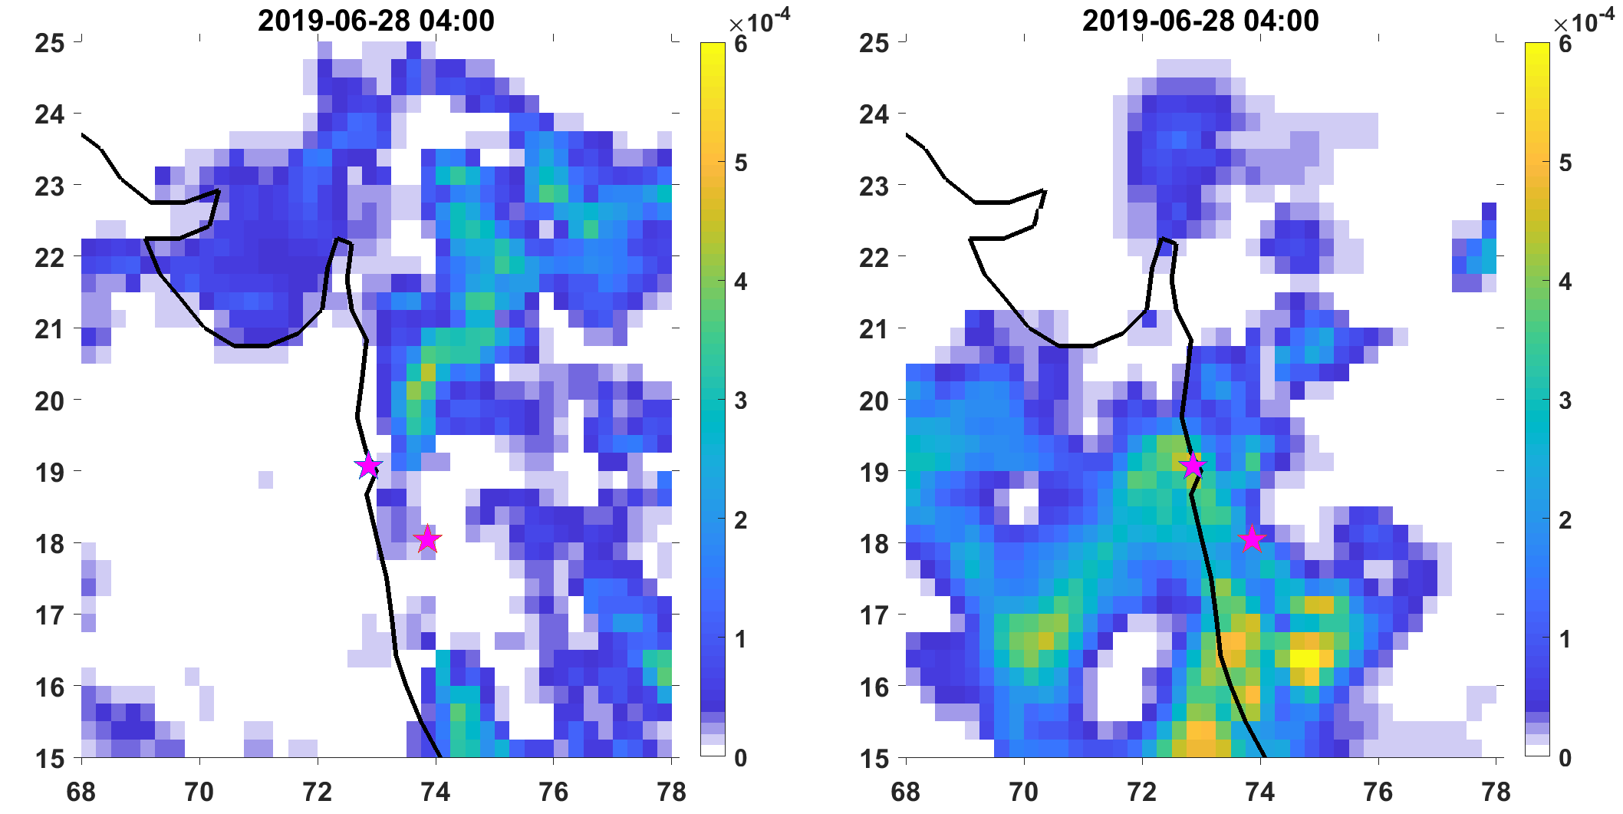

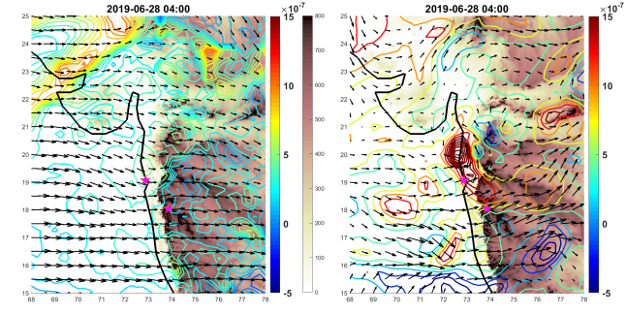

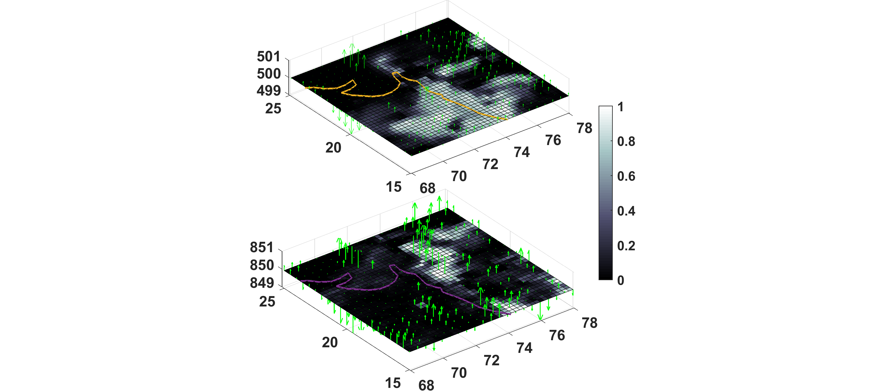

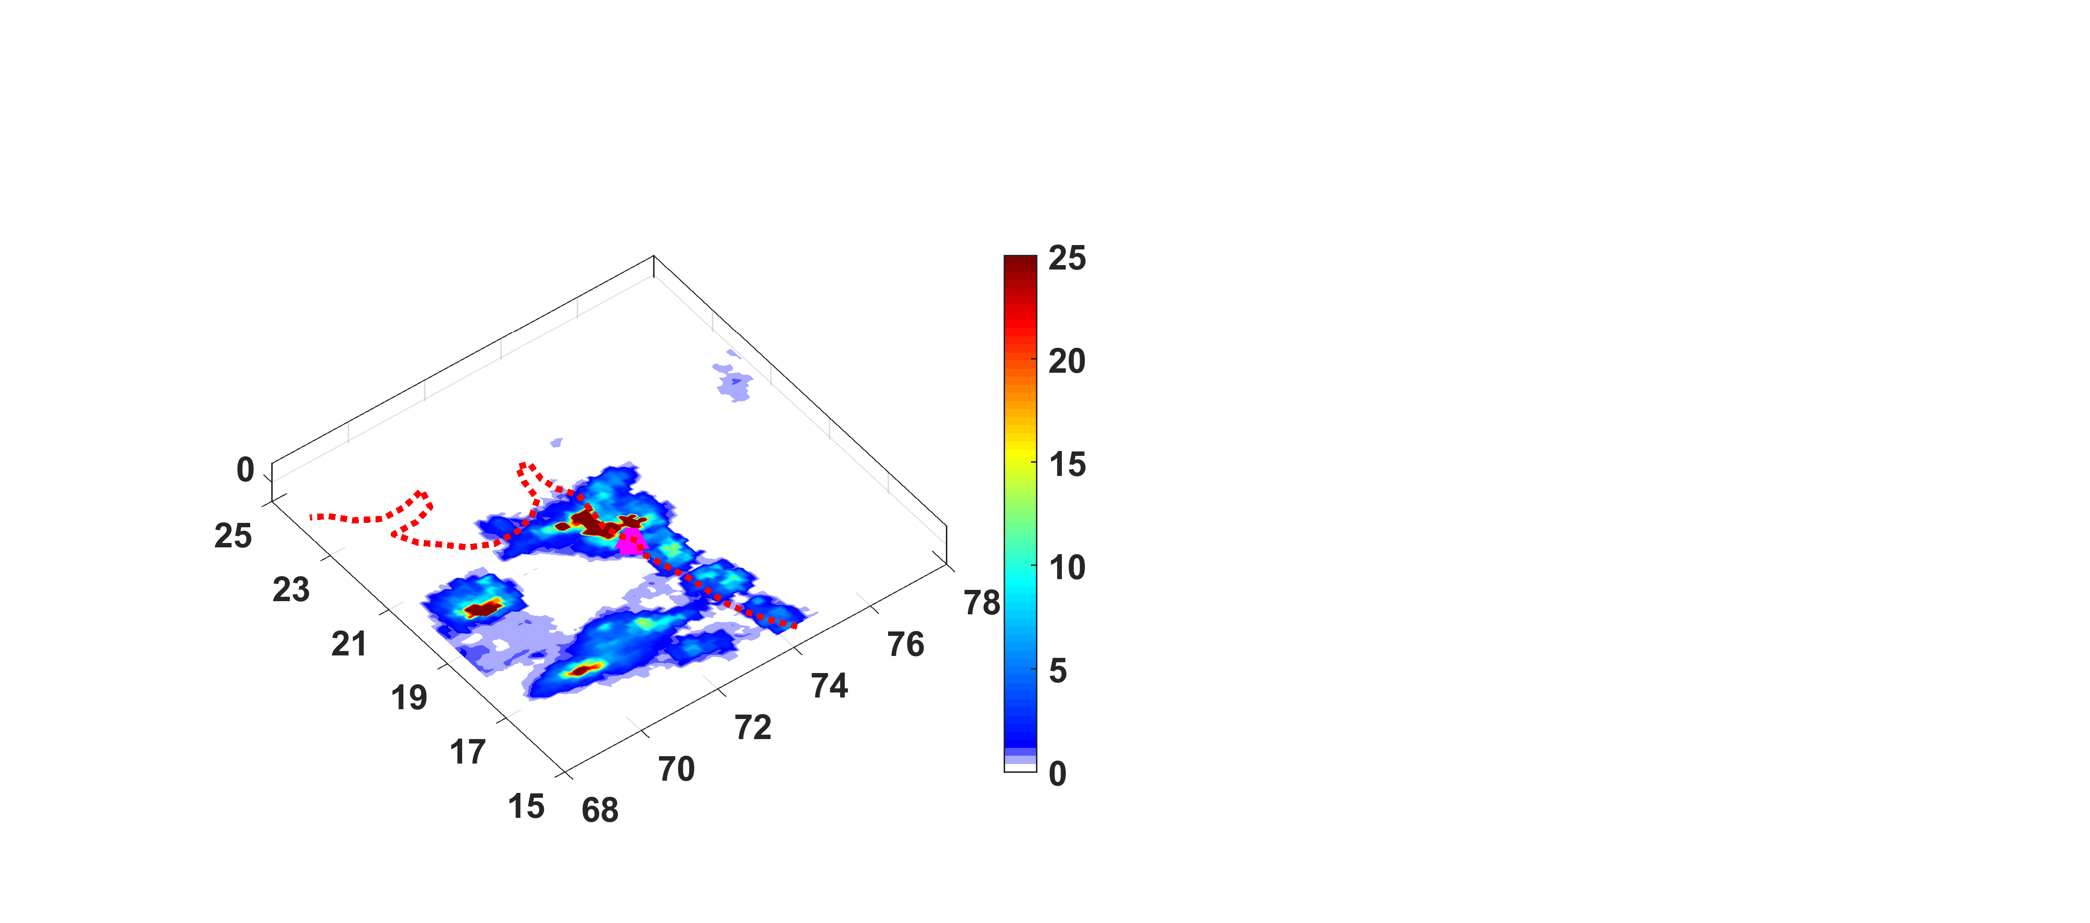

Figure 6. The temporal coherence between sub daily scale variability of EREs and its controlling attributes during an extreme rainfall event.

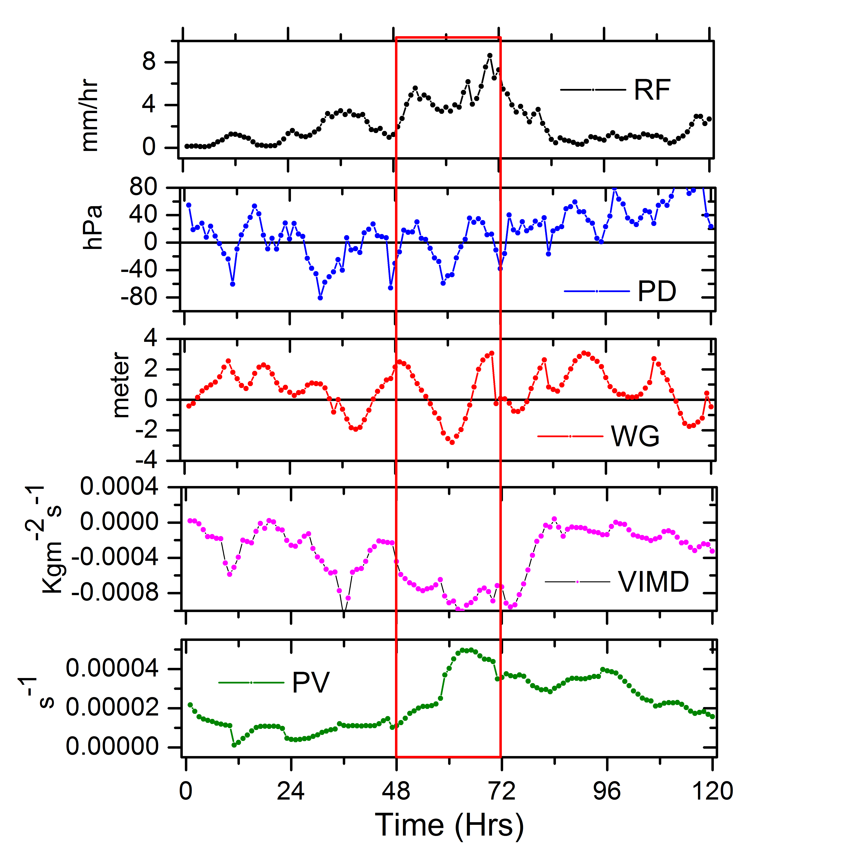

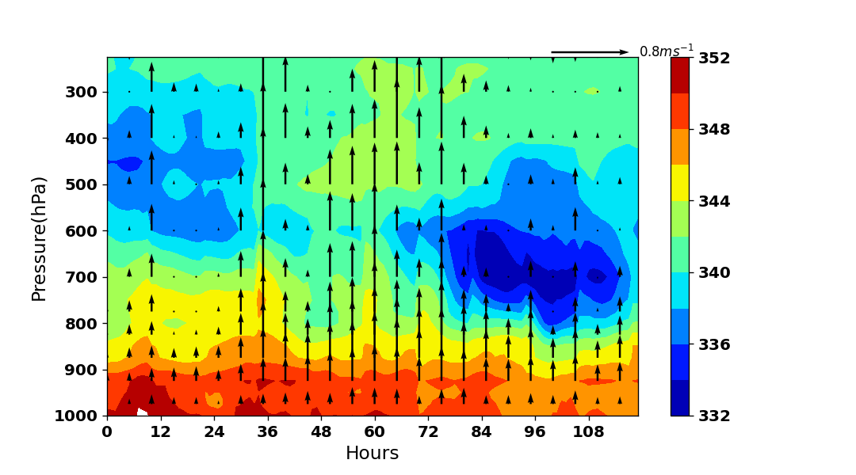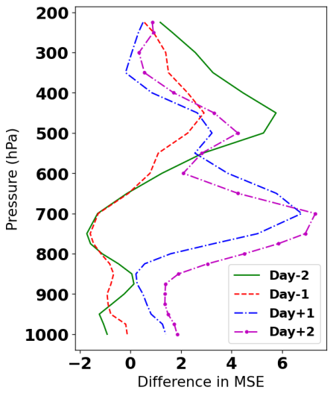Figure 7. Two dimensional distributions of moist static energy (figure 6a) and its anomaly (figure 6b) on different phases of extreme rainfall event. In figure 6a, the up arrows represent the strength of the updrafts during different phases of the extreme rainfall event.

Figure 8. Two dimensional distributions of Ice Water Content (IWC) and Liquid Water Content (LWC) on different phases of extreme rainfall event.

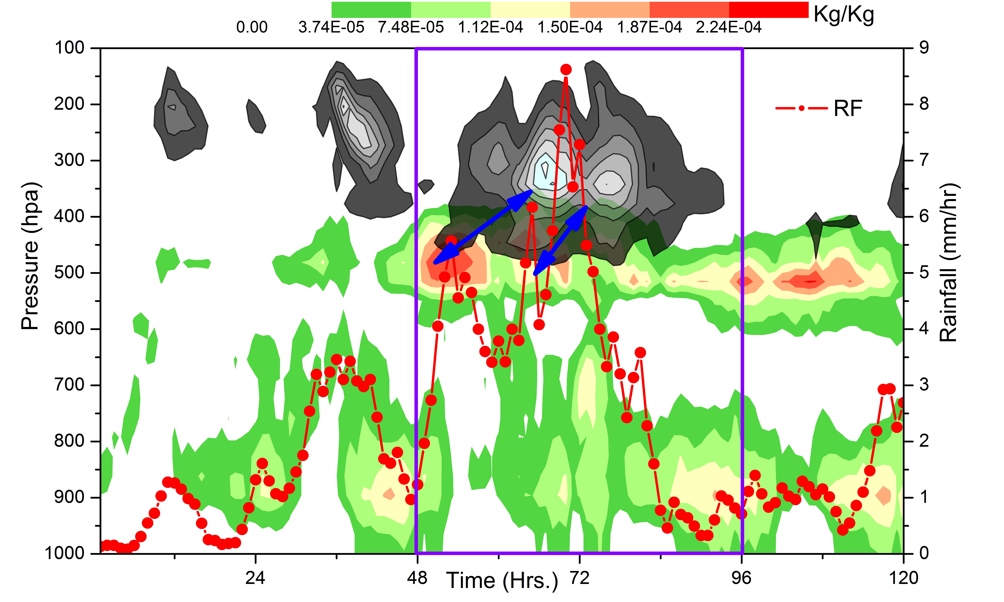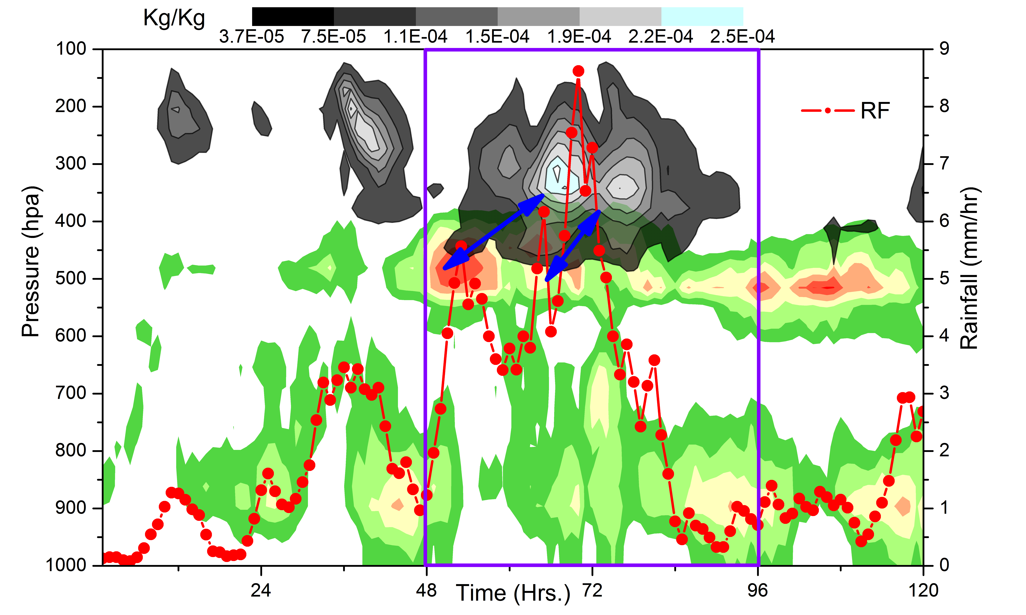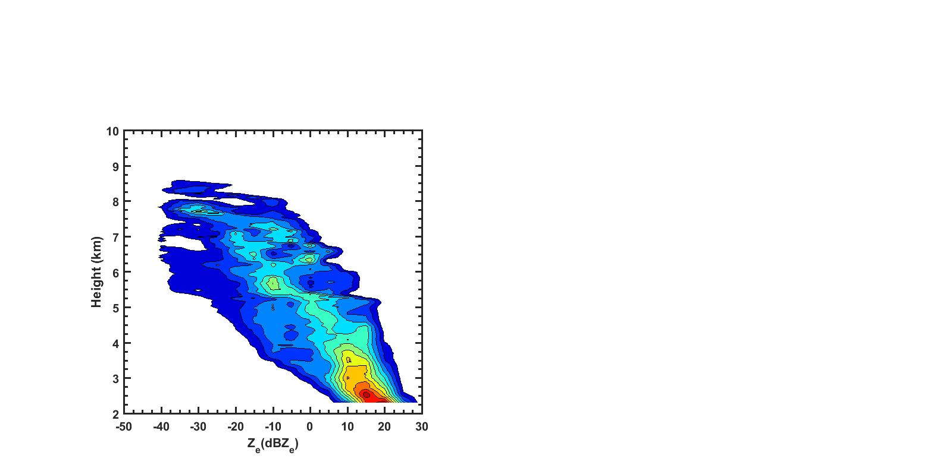

**[ e ]**

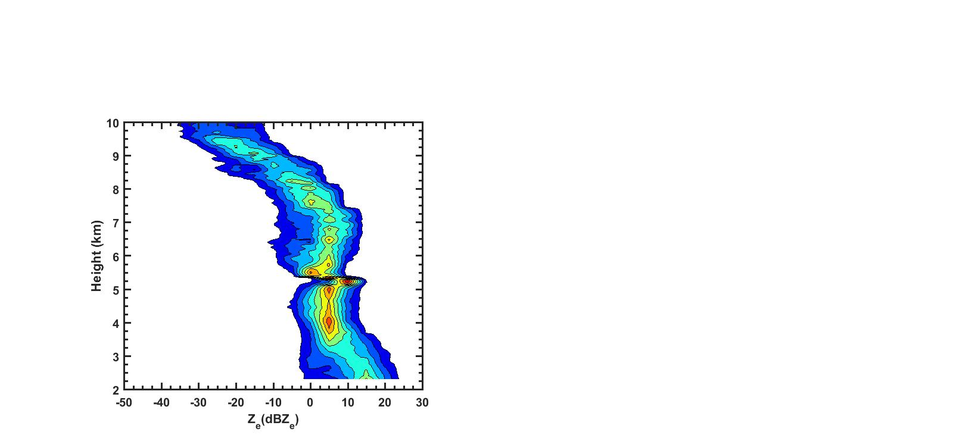

**[ d ]**

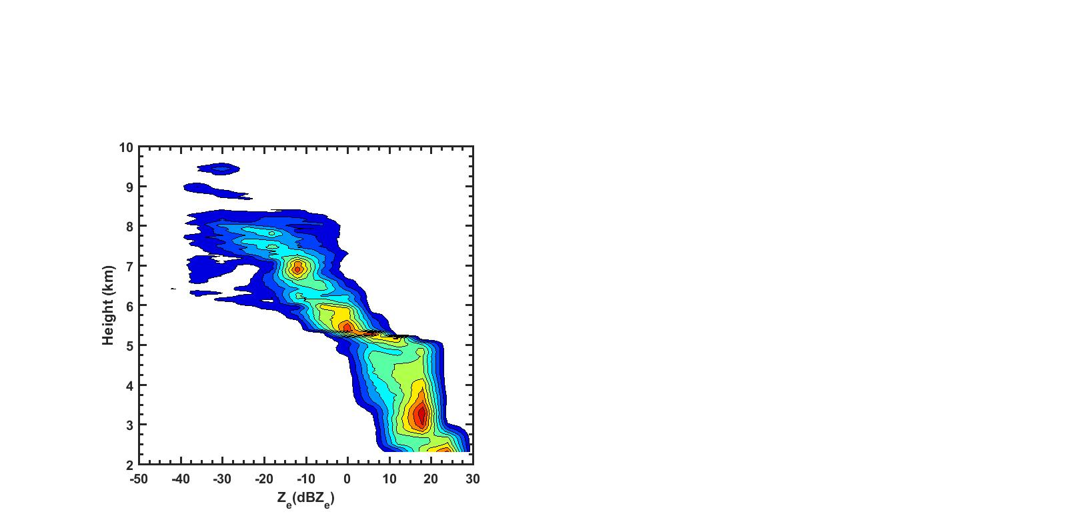

**[ c ]**

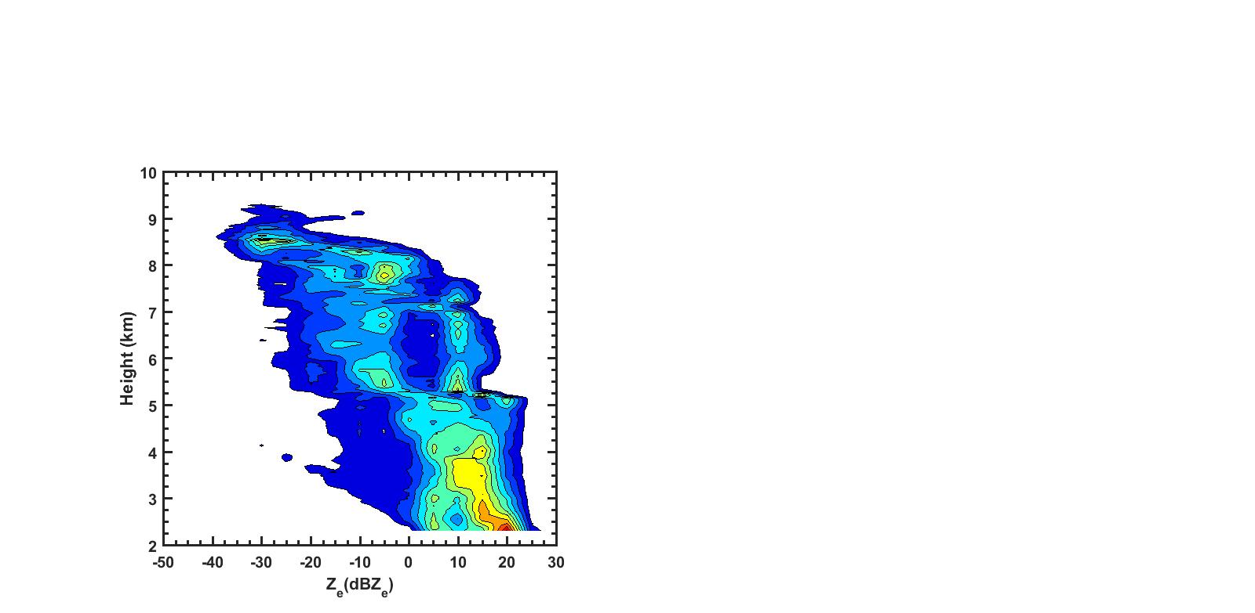

**[ b ]**

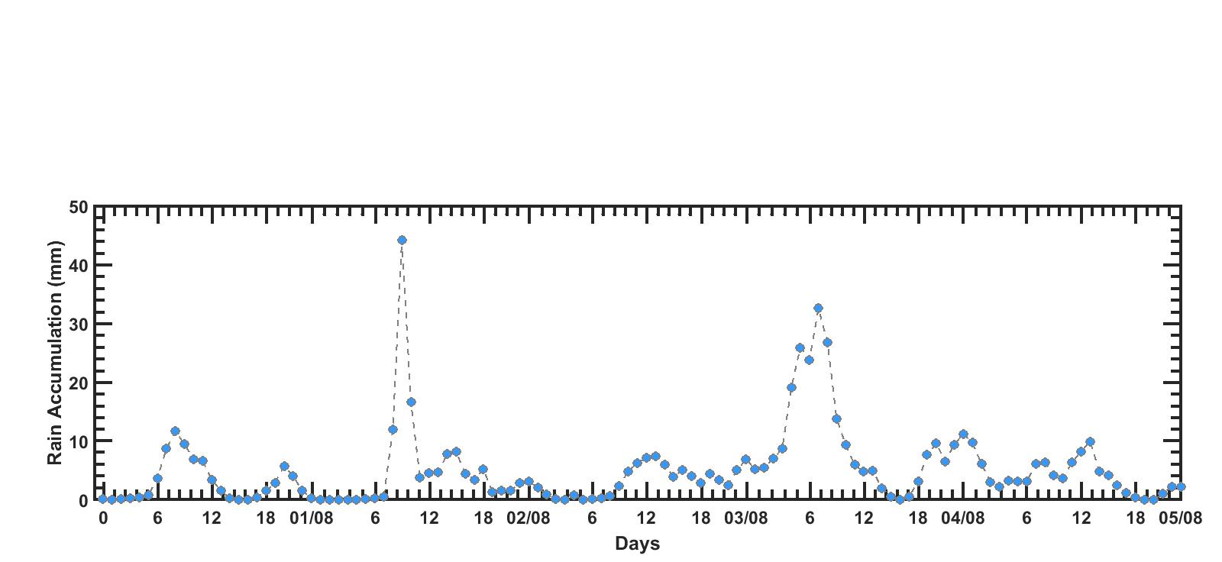

**[ a ]**

Figure 9 (a) Hourly rain accumulation from multi satellite based precipitation estimates from gauge calibration for a 5 days extreme event period from 01 Aug to 05 Aug 2019 over Mandhardev, WGs. The three boxes represent the rain accumulation at the initial, medium and dissipating stage of the extreme event for which (b-d) Contoured frequency by altitude diagram (CFAD) of Ze from co-located vertical looking measurements of KaSPR is analysed.



**[ a ]**

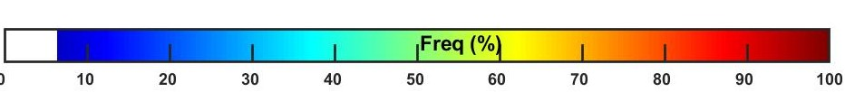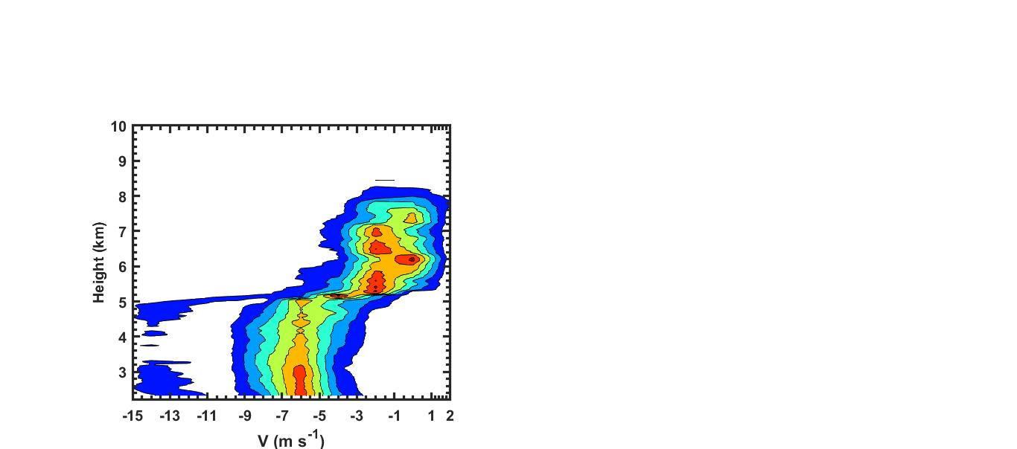

**[ e ]**

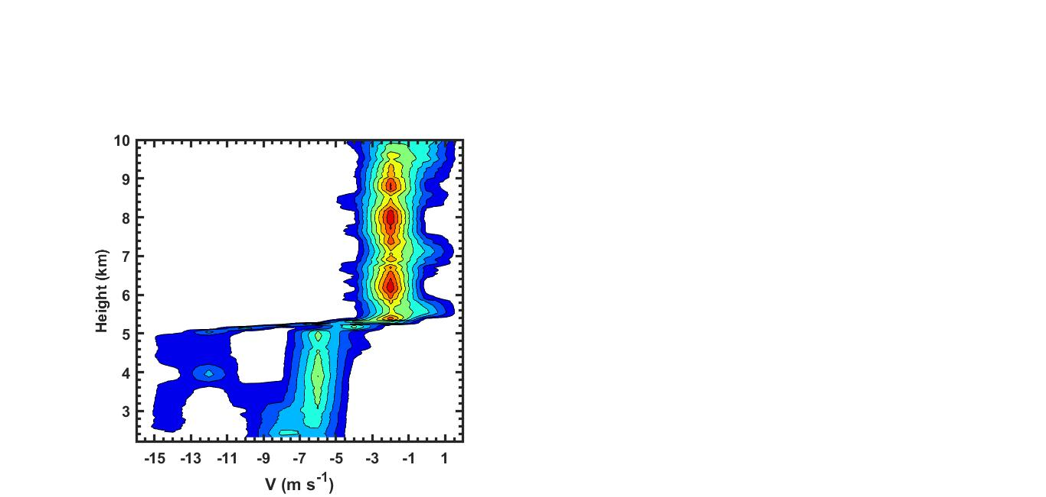

**[ d ]**

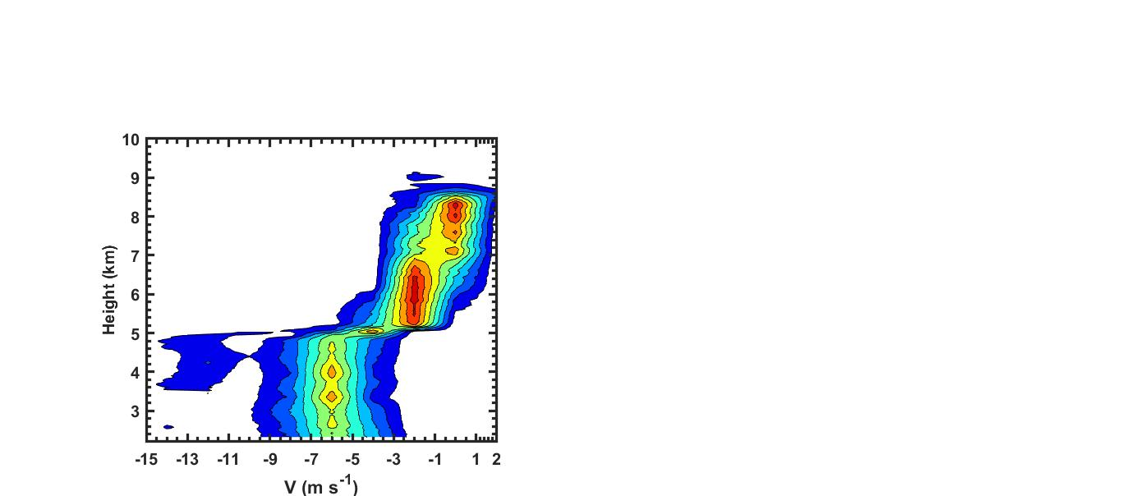

**[ b ]**

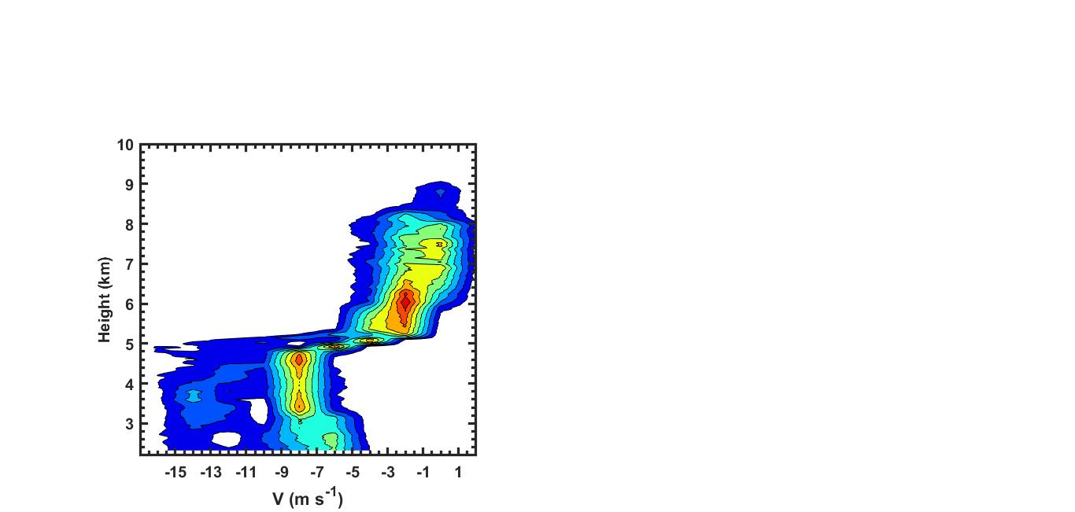

**[ c ]**

**[ c ]**

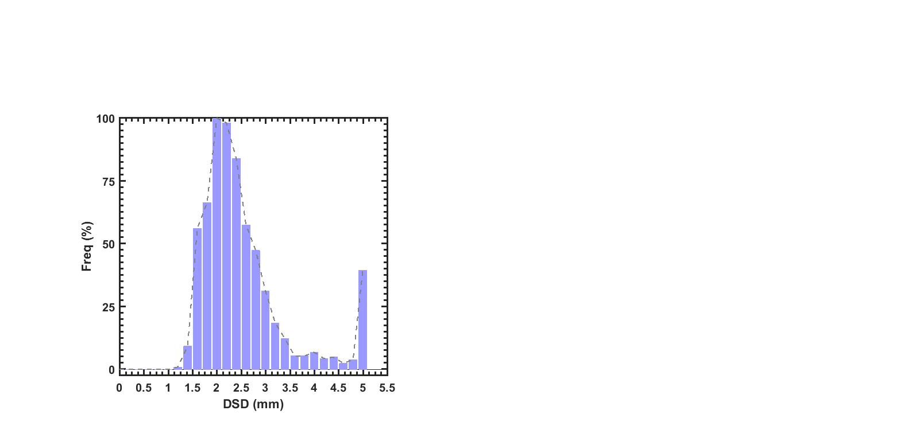

**[ b ]**

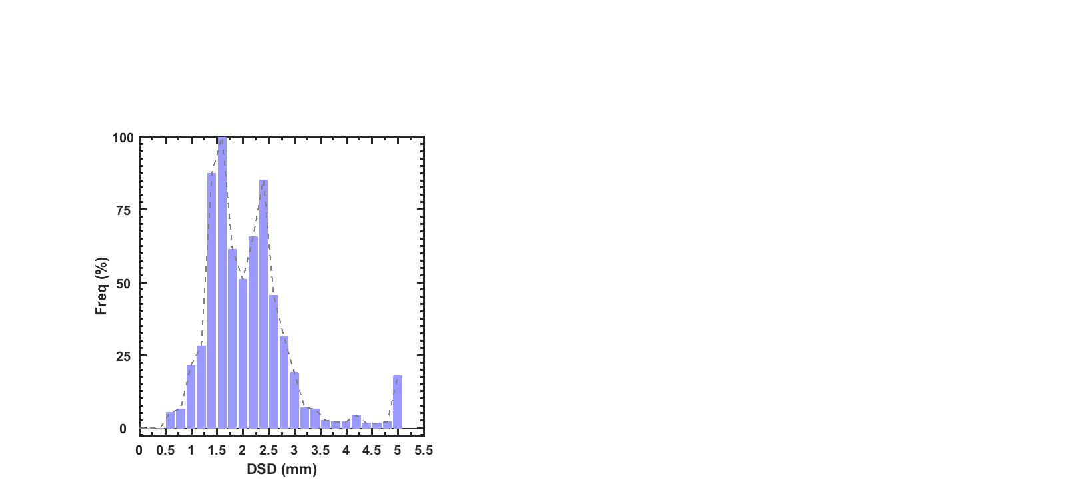

**[ a ]**

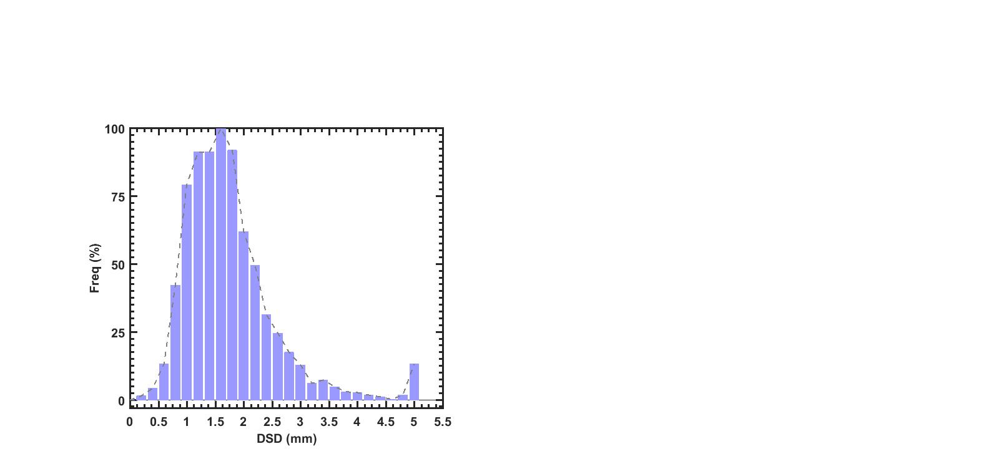

**[ d ]**

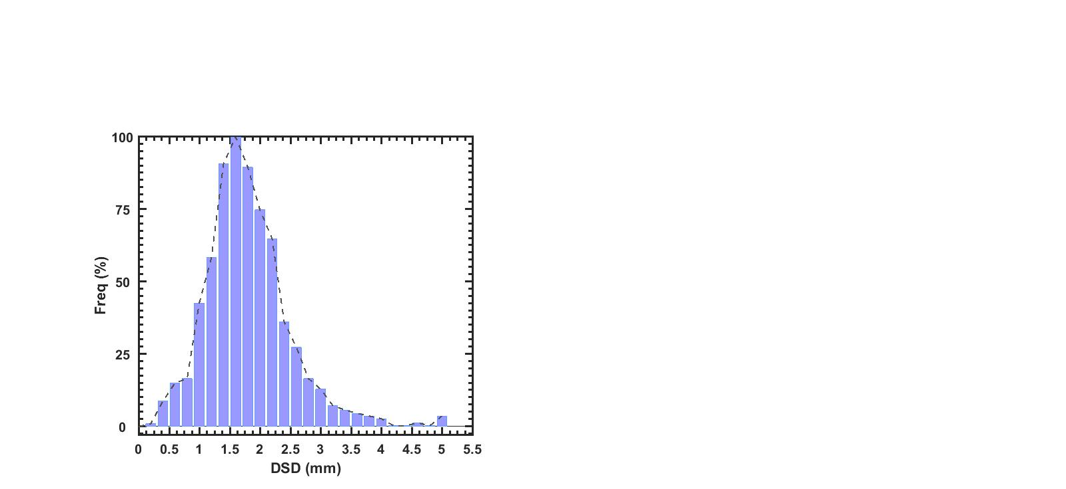

Figure 11(a-c) estimated DSD from KaSPR velocity observations at the lowest range bin (2.2 km) using Gunn and Kinzer’s (1949) formula at the initial, medium and dissipating stage of the 5 days extreme event from 01 Aug to 05 Aug 2019.

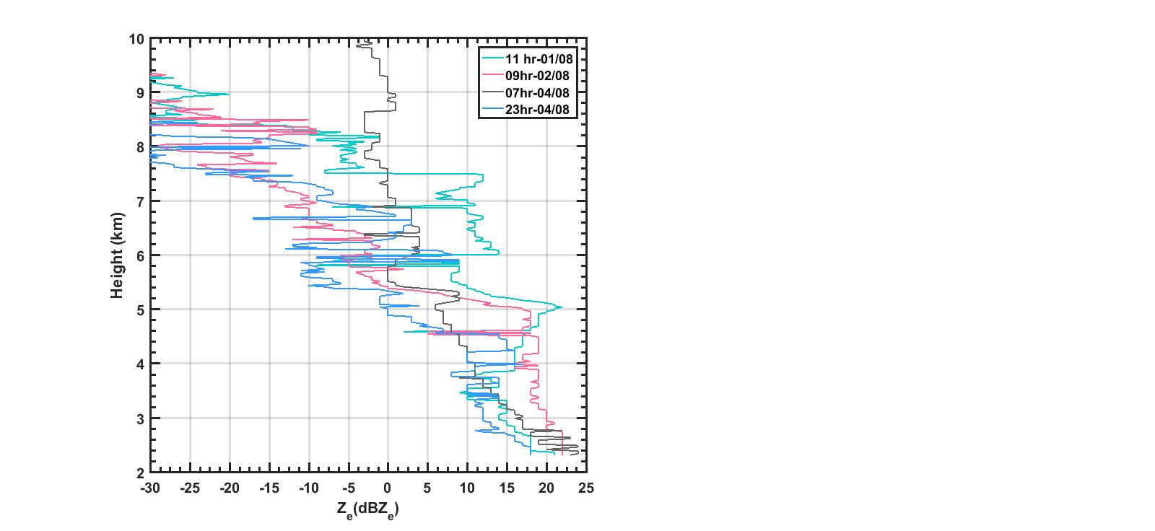

Figure 10 Same as Figure 7 but for vertical velocity.

Figure 12. Vertical profiles of mode Ze during different phases of the extreme rainfall event over study region

Figure-13. Composite analysis of the temporal coherence between sub daily scale variability of EREs and its controlling attributes.

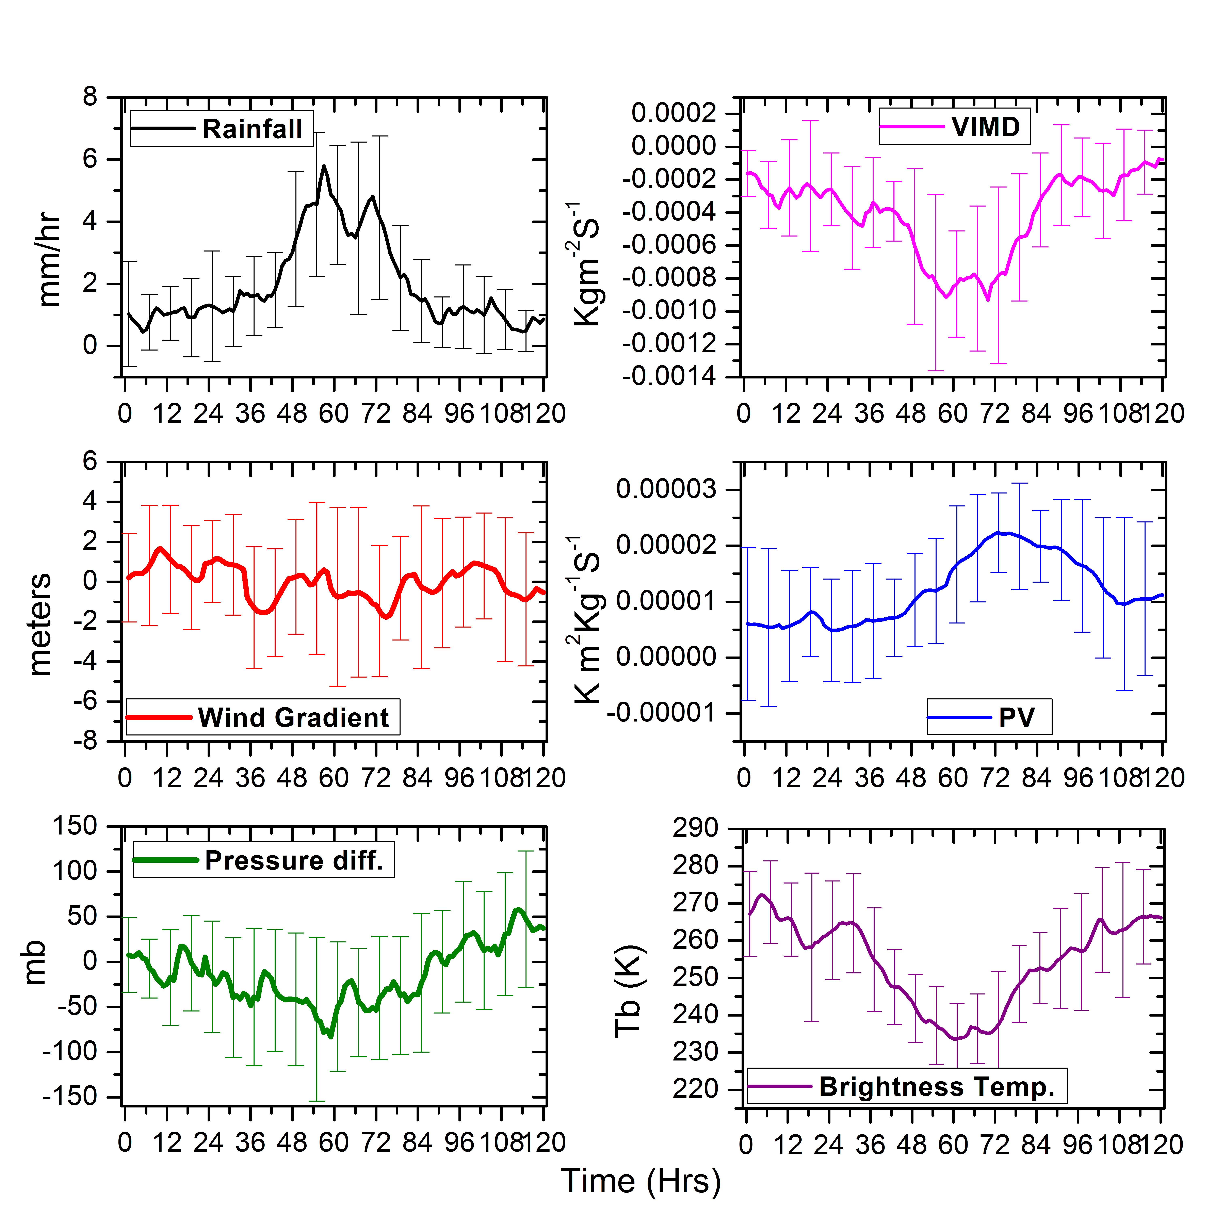

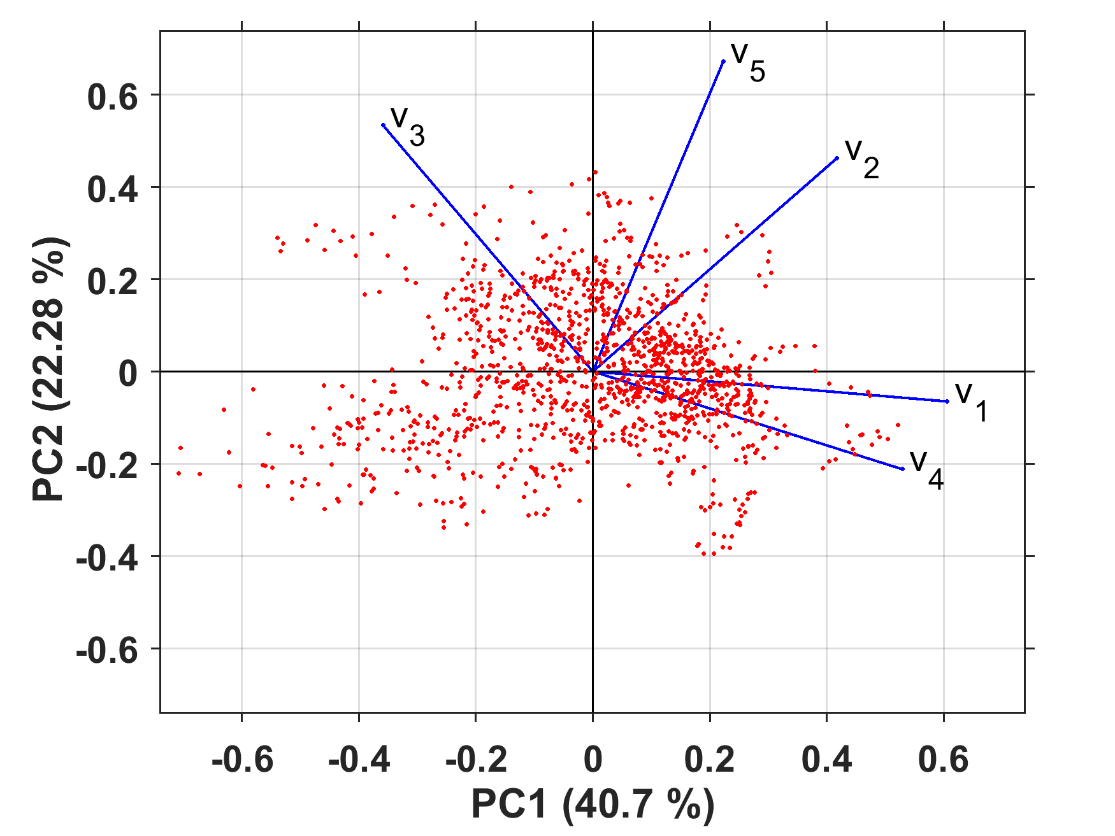

Figure-14. Biplot shows the first two principal components and possible attributes in terms of vectors.

Table-2. First four PCs and the corresponding loading scores of each attribute.

|  |  |  |  |  |  |  |
| --- | --- | --- | --- | --- | --- | --- |
|  |  |  | **1** | **2** | **3** | **4** |
| Moisture convergence (V1) |  |  | 0.864344 | -0.06855 | 0.07493 | -0.15338 |
| Offshore trough (V2) |  |  | 0.595717 | 0.488494 | -0.39907 | 0.495129 |
| MTC (V3) |  |  | -0.51211 | 0.563617 | -0.51864 | -0.35371 |
| Brightness Temperature (V4) |  |  | 0.754835 | -0.22363 | -0.36653 | -0.37393 |
| Wind gradients (V5) |  |  | 0.318115 | 0.709446 | 0.578514 | -0.19261 |
|  |  |  | 40.7 | 22.28 | 18.05 | 11.41 |