**Towards understanding of controlling factors on sub-daily scale variability of extreme rainfall intensity over west coast in India**

K.Sunil Kumar*, Sukanya Patra, Meenu Nair, M.C.R. Kalapureddy and G.Pandithurai

Indian Institute of Tropical Meteorology, IITM, Pune, Ministry of Earth Science, India, 411008

*Correspodning:sunil.khadgarai@tropmet.res.in

**Abstract:** Unlike in daily precipitation, variation in Extreme Rainfall Events intensity on a sub-daily scale is governed by fast response thermodynamics. Understanding of causative mechanisms and controlling factors responsible for the rapid intensification of rainfall intensity on sub-daily scale is still inadequate. Here, we show that the vertically integrated moisture flux convergence supplemented by the strong updrafts and deeper clouds responsively influences the hourly rain rate distribution. The mid-troposphere moistening during the mature phase of the ERE’s amplifies the hydrometeor growth mechanisms as revealed by cloud liquid/ice water content distribution and radar reflectivity profiles. A sloppy and narrow radar reflectivity pattern above zero degree isothermal suggests a contrast cloud vertical structure during intense phase of the ERE’s.

**Introduction**

Climate change has profound effect on water cycle, as warming atmosphere holds more moisture. Consequently, the nature of rainfall duration has been modulated though its intensity, and frequency. Extreme rainfall events (EREs) are severe weather phenomena which brings substantially excess of rainfall than normal on different temporal scales. In recent decades, climate change due to the global warming is remarkably reflected in the higher frequency of occurrence of EREs [Sunil Kumar et al., 2021;]. Hence, EREs are turned out to be socially concerned natural hazards. In India, EREs are often associated with flash floods, prominently in urban regions, river basins, and landslides along hilly regions. EREs occur due to various synoptic and meso-scale weather systems such as atmospheric rivers, Mesoscale Convective Systems, atmospheric rivers, tropical cyclones, and cloud burst over the tropical region. Several disaster reports and previous studies claim that, EREs cause substantial societal and economic loss in various regions including India [https://public.wmo.int/en/media/news/rainfall-extremes-cause-widespread-socio-economic-impacts, Kamaljit ray et al., 2021]. Flash floods caused by cloudbursts/EREs are one of the natural disasters that cause maximum mortality in India [Kamaljit ray et al., 2021]. Nevertheless, the quantification and predictability of EREs have become challenging owing to a lack of detailed understanding on the physical process that governs the nature of EREs ideally on sub daily scales.

As EREs are becoming a rising concern for global community, numerous studies were attempted to understand EREs evolution, possible physical mechanisms, and trends subjected to different climate change scenarios [Barlow et al., 2019; Bhattacharyya et al., 2022; Zou et al., 2021; Nikumbh et al., 2019]. Both modelling and observational approaches have been employed to investigate the evolution of EREs on regional and continental scales. From these studies, it is learnt that the nature of EREs is primarily influenced by the amount of water vapour transported large scale systems during the event evolution. Increasing in the water vapour content as result of global warming according to Clausius -Clapeyron equation turns out the rainfall events much intensified and short duration. However, the relationship between EREs variability and water vapour content cannot holds good if the other important thermo dynamical attributes such as temperature, vertical updrafts and adiabatic lapse rate when plays a major role as evidenced by the observations and global models. Moreover, the global model simulations are not able to follow such thermodynamic relationship between water vapour and EREs mostly over tropical regions due to their incapability of resolving convective processes (Westra et al., 2014; o groimann 2009). Hence, further understanding of the EREs in the light of their association with other possible attributes certainly improves our understanding these systems and hence the model simulations. The observed trends in EREs concerning different geographical regions and spatiotemporal scales are inconclusive, as insignificant increasing/decreasing trends were reported [Ghosh et al., 2016]. The possible physical and dynamic attributes for such mixed trends, unlike other parameters such as temperature, are still a subject for open dissuasion.

As India is concerned, the frequency of occurrence of EREs, in general, is predominant during the Indian Summer Monsoon (ISM) season from June to September. The seasonal rainfall (June. July, August, and September, JJAS) exhibits a relatively heterogeneous regional distribution in India (Sunil Kumar et al., 2021; Ghosh et al., 2009). For instance, West Coast India and North East India regions receive copious seasonal rainfall than the other regions. Though the EREs in the summer season are reported annually in India, the West Coast region is much more vulnerable to such EREs owing to various physical, dynamic, and geographical reasons [ Rupa Kumar et al., 2006; Francis et al., 2006]. However, the most influencing factor is the series of mountains along the west coast. These mountain barriers act as a catalyst to enhance precipitation mechanisms along the west coast region. When large-scale monsoonal wind flow enriched with moisture from the Arabian Sea interacts with these sloppy mountains, wind flow encounters an orography lift. Hence clouds formation becomes more feasible. Thus, the land regions along the windward side of the Western Ghats receive copious rainfall, possibly with few extreme spells. Such extreme spells often cause flash floods and havoc along the west coast region [Vijaykumar et al., 2021; Jitnedra sing et al., 2017].

In India, numerous attempts were made to investigate EREs possible trends and spatiotemporal variability using both observational and modelling approaches [Ajaymohan and Rao., 2008; Haider Ali et al., 2014; Sardana et al., 2022; Patnaik and Rajeevan , 2010; Rajeevan et al., 2008]. Rajeevan et al., 2008 explored the link between EREs and the SST over Indian Ocean and concluded that the SST modulates the possible trends and variability of EREs over the tropical ocean. Using IMD-generated rain gauge-based gridded product, the trends and spatiotemporal variability of EREs are attempted by Patnaik and Rajeevan 2010; Goswami e al., 2007; vital et al., 2013; Srivastava et al., 2016; Jain et al., 2022; Guhathakurta et al., 2011]. The important conclusion from these studies highlights the recent increase in EREs, significantly post-1980 in India. It is also stated that the increasing tendency in EREs is comparatively more significant than the mean seasonal rainfall in India [Patnaik and Rajeevan, 2010]. On average, the detected trends showed a possible increase in 24 hr rainfall and wetting trend in India [Sen Roy and Balling, 2004]. However, on the regional level, the trends show an increasing signal in peninsular, east, and northeast India and decreasing tendency in central India and north India.

Despite the substantial progress in understanding the day-to-day, decadal variability, and long-term trends in EREs in India, previous studies focussed on EREs on daily scales. Nevertheless, it is observed that rapid hydrological processes such as flash floods are often associated with sub daily extremes. The evolution of EREs on sub-daily scales is rather limited to fewer studies due to the unavailability of reliable rainfall data on the sub-daily scale. Though, few recent literatures investigated the sub-daily scale variability of rainfall, they addressed characteristics of mean rainfall rather than extreme rainfall events over selected regions [Kamaljit Ray et al., 2016]. However, when it comes to EREs, the key features of daily EREs are not necessarily applicable to the sub-daily scales in several respects. The inapplicability of empirical relations between rainfall water vapour and temperature on sub-daily scales and the set of physical processes that govern the rapidly intensified sub daily EREs are significant aspects that eventually furcate EREs on sub-daily scales from daily EREs. Sub-daily precipitation extremes may intensify more than anticipated based on currently available modelling and theory [Lenderink and van Meijgaard, [2008](https://agupubs.onlinelibrary.wiley.com/doi/10.1002/2016GL071917#grl55414-bib-0042); Hardwick-Jones et al., [2010](https://agupubs.onlinelibrary.wiley.com/doi/10.1002/2016GL071917#grl55414-bib-0028)]. This seems to be a property of convective precipitation and may be explained by the latent heat released within storms invigorating vertical motion. Such mechanism is thought to generate greater increases in hourly rainfall intensities [Lenderink and van Meijgaard, [2008](https://agupubs.onlinelibrary.wiley.com/doi/10.1002/2016GL071917#grl55414-bib-0042);  Hardwick-Jones et al., [2010](https://agupubs.onlinelibrary.wiley.com/doi/10.1002/2016GL071917#grl55414-bib-0028); Westra et al., [2014](https://agupubs.onlinelibrary.wiley.com/doi/10.1002/2016GL071917#grl55414-bib-0076); Blenkinsop et al., [2015](https://agupubs.onlinelibrary.wiley.com/doi/10.1002/2016GL071917#grl55414-bib-0009)], with a stronger response in convective systems than in stratiform systems [Berg et al., [2013](https://agupubs.onlinelibrary.wiley.com/doi/10.1002/2016GL071917#grl55414-bib-0008)]. This suggests that hourly extremes will probably intensify more with global warming than daily extremes [Utsumi et al., [2011](https://agupubs.onlinelibrary.wiley.com/doi/10.1002/2016GL071917#grl55414-bib-0068); Westra et al., [2014](https://agupubs.onlinelibrary.wiley.com/doi/10.1002/2016GL071917#grl55414-bib-0076)]. The results from daily-scale observational or modeling studies therefore are unlikely to be directly transferrable to sub daily time scales. On comparing the possible projections, the potential of increasing the intensity of sub daily extremes is elucidated in recent articles [Lenderink and van Meijgaard, 2008; Fowler et al., 2021; Westra et al., 2014]. As a result, the uneven temporal distribution of EREs magnitude on sub-daily scales is responsible for the fast hydro-meteorological process, such as flash floods and cloud bursts which are more hazardous than slower onset floods because of very limited response time. Parameterization of such fast hydrological processes certainly needs the better understanding of EREs evolution on sub-daily scales. Hence, understanding the potential drivers responsible for sub daily scale variability of EREs on regional scale provides basis for impact based risk assessments.

The evolution of EREs over the Indian West coast is documented in previous studies [Deshpande et al., 2012; Xavier et al., 2018; Kottayil., 2021; Sunil Kumar et al., 2022; Francis et al., 2006; Ray et al., 2016; Meenu et al., 2020]. These studies addressed the evolution of EREs and possible physical attributes and associated systems. Deshpande et al., (2012) observed that many stations recorded more than 10 cm within span of 1 hr and 80% total daily rainfall is accumulated within 12 hours. Kottayil et al., (2021) concluded that the EREs over west coast are well associated with the behaviour of LLJ and mid-troposphere humidity levels. Francis et al., (2006) investigated the possible synoptic systems related to heavy rainfall events on a daily scale. The possible cloud microphysics and physical mechanism responsible for Kerala floods 2018 is discussed in Meenu et al., 2020. However, studies on the sub-daily variability of EREs and their association with different controlling elements are still lacking over the West coast. Atmospheric processes occurring at various scales such as cloud droplet formation and cloud growth at the microscale, help to have detailed understanding of such heavy rainfall events. Since, cloud radar is sensitive to cloud droplets, and ice crystals because of their short wavelengths. Hence, in this study ground based cloud radar is utilised to decipher cloud microphysics pertinent to EREs by studying the cloud evolution. In the present article, we subjectively diagnosed the variability of EREs on sub-daily scales and its controlling factors using a suit of observational approaches such as high-resolution satellite, reanalysis, rain gauge network, and ground based cloud radar data.

The manuscript is organized as follow. With a brief background literature review, datasets and methodology used in the present study are discussed in section 2. Results and discussions are described in section 3. Essential conclusions from the current study are mentioned in section 4.

**Results and Discussions**

West Coast India, one of the country's wettest regions, receives ~300 cm to 400 cm of rainfall during JJAS. The spatial distribution of seasonal rainfall during JJAS months suggests inhomogeneity in seasonal accumulation [Sunilkumar et al., 2016]. Due to orographic influence and rich moisture source (Arabia Sea) the wind ward side receives ample amount of seasonal rainfall. West Coast India stands as a tested for many meteorological studies since the signature of ISMR is first ever observed over this region.

**Rainfall characteristics on sub daily scales**

Figure 1b depicts the seasonal rainfall accumulation over the west coast region in 2019. The coastal region receives relatively more seasonal rainfall than the leeward side of the mountains. The strong dynamical interaction of monsoon winds with orography phenomenally results in copious rainfall over the west coast region. In general, several long-duration wet spells during monsoon over the west coast region significantly contribute to the seasonal rainfall accumulation. However, numerous literatures reported that the duration of such active rain spells has decreased in recent decades [Vinay kumar et al., 2021; Sunil kumar et al., 2022]. In recent decades, it is also observed that the west coast region encountered a significant change in the distribution of rainfall active and break ISM spells. Thus, despite a insignificant trend in mean seasonal accumulation, the number of heavy to extreme rainfall events witnessed a significant increasing trend over west coast region [Renaud Falga and Chien Wang, 2022; Sunilkumar et al., 2021; Francis and Gadgil., 2006]. Figure 1d shows the rainfall fraction contributed by the heavy to extreme rainfall events to total seasonal rainfall in 2019. From the Figure 1d, it is clear that more than 40 % of seasonal rainfall is contributed by heavy to extreme rainfall events over a significant fraction of land region over the west coast. It is interesting to note that such rainfall contribution from EREs is much more prominent around the Mumbai metropolitan region in 2019. Thus, we have considered a high temporal resolution (15 minutes) rain gauge data from MESONET to further explore the sub-daily scale variability of EREs rainfall intensity over Mumbai region. Sub daily scale variability of mean rainfall of extreme nature over Mumbai and surrounding regions is presented in Figure S1. Figure S1also illustrates the number of mini cloud bursts (accumulated rain>50 mm in two consecutive hours) that occurred on sub-daily hours over Mumbai. The occurrence of mini cloud bursts is considered to relate the mean rainfall characteristics to the intense nature of rainfall events. The sub-daily scale variability of mean rainfall suggests a uniform distribution of rainfall except during evening to late evening hours. However, the primary peak of occurrence with mini-cloud bursts is around midnight to early morning hours and secondary peak is just around late afternoon hours. Such intense nature of rainfall event last for a few hours and result in an ample amount of rainfall that often leads to flash floods, particularly in urban regions (Hayley et al., 2021; Meyer et al., 2021; Kristian FörsterLuisa and Bianca Thiele, 2020). Though, the dynamical and thremodynamical attributes in previous studies were considered to understand the nature extreme rainfall event on daily scales, the physical mechanisms that governs the rapid intensification of rainfall on sub daily scales is poorly understood (Kristian FörsterLuisa Bianca Thiele, 2020). Therefore, it is imperative to understand the possible dynamical and thermo dynamical process that regulates the variability of extreme rainfall intensity on sub-daily scale.

Several such extreme rainfall events based on average regional rainfall recorded during the last decade (2010-2020) are selected over the study region. Table S1 shows the list of extreme precipitation events occurred along the west coast during 2010-2020. The seasonal distribution of such extreme events is shown in figure 2a. Six of 11 events occurred in July and August, which are active monsoon months over the west coast region. The basis for defining an extreme rainfall event is relaxed to 80 mm/day to evaluate the monthly distribution of such extreme rainfall events. The seasonal distribution of such events is shown in figure 2b. The seasonal distribution suggests that the frequency of EREs is higher in July and August than in the June and September months. It can be stated that extreme events are well associated with the active phase of monsoon (July and August) and are less observed during the onset and withdrawal phase of monsoon (June and September).

We have considered one such case study of a heavy rainfall event spell that occurred from 26th Jun to 30th Jun, 2019 over the study region. Figure 1c depicts one day accumulated rainfall on 28-06-2019 over west coast region. The maximum accumulated rainfall observed over west coast region is ~300 mm/day during active phase of the event, i.e. on 28-06-2019. Figure 2c depicts the regional mean rainfall recorded on different days during the spell. The event commenced on 26th June with light rainfall magnitude ~13 mm, and the daily rainfall subsequently increased on next two days and then started dissipating on 29th Jun 2019 over the study region. The study region received the highest area average rainfall (~117 mm) in 28-06-2019. High resolution satellite rainfall estimates such as GPM-IMERG is useful to analyse the sub daily scale variability of rainfall. Figure 2d shows the sub-daily scale variability of average areal rainfall on 28-06-2019. The rainfall activity is intensified during midnight hours compared to other sub-daily hours. The predominant occurrence of such enhanced rainfall activity during mid night hours is also shown in Figure 2d and discussed in Sunilkumar et al., 2022. Though, the presence of rainfall activity is seen throughout the day, the intense nature of the event (8mm/hr) is observed for few hours during night time. With reference to previous literature survey, we considered several possible attributes, such as moisture convergence, presence of offshore trough, wind gradients, Specific cloud liquid/ice water content, Moist static energy and etc, to quantify the influence of such attributes on sub-daily scale variability of extreme rainfall intensity over the study region

**Case Study on 28th, Jun 2019**

The sub-daily scale variability of extreme rainfall intensity depicts a bimodal distribution within 24 hours, as shown in figure 2d. The bimodal distribution of rainfall magnitude certainly associates with several dynamical attributes. Various attributes possibly linked to rain intensity are considered during peak rain intensity hours (mid night) to explore the spatial connectivity. Figure S2 illustrates the spatial variability of rainfall intensity over the west coast on 28th, Jun, 2019 at 4 LT, along with several high resolution background dynamical parameters such as wind pattern, vertical updrafts/downdrafts, cloud liquid water content, cloud ice water content, cloud fraction, integrated moisture convergence, cloud top brightness temperature and relative vortices. All these parameters are considered at 850 and 500 hPa pressure levels, to understand the co-variability of rainfall intensity spatial distribution with dynamical parameters at the lower and mid-troposphere. The spatial distribution of rainfall intensity (~20 mm/hr) suggests intense rainfall activity over the West coast region. The spatial wind pattern at the lower/mid-troposphere represents winds heading towards the west coast region and a cyclonic vortex at the mid-tropospheric level north to rainfall active zone as shown in Figure S2a and S2b. Low-level convergence of monsoon winds results in upper-level divergence, leading to cyclonic vortex at upper levels. Mid-tropospheric total cloud fraction also depicts cloud activity along the west coast region. The spatial differentiation between maximum cloudiness and rainfall over grid points is attributed to the lead-lag relation of cloud activity and rainfall at the surface. The spatial variability of rain rate is well associated with regions of strong vertical drafts and specific cloud liquid/ice water content as represented in Figure S2 (e-h). The intense nature of convection during peak rain hours is reflected in terms of low brightness temperature (< 240 K) as shown in Figure S2i. Hence, the intense nature of rainfall is often associated with deep convective systems as reported in earlier literature (Remy Roca and Thomas Fiolleau, 2020; Meenu et al., 2020). The strong moisture convergence over the observed maximum rain intensity region suggests a strong influence of the moisture availability on surface rainfall intensity as referred from Figure S2j. From Figure S2d, it is observed that the cloud fraction at mid-tropospheric levels is well connected with strong convection (negative omega) along west coast regions. The phenomenal relation between strong convection and cloud fraction at mid-troposphere is also demonstrated in a 3D sub plot, as shown in Figure S2 (k-l). Interestingly, the spatial distribution maximum rainfall intensity is well associated with strong convection (negative omega) at the surface level. Comparing the spatial distribution of pressure velocity, cloud fraction, and rainfall intensity, it is observed that the intense nature of surface rainfall is associated with significant moisture convergence, strong updrafts and deeper clouds.

Further, to understand the role of various dynamical parameters on sub daily scale variability of rainfall intensity, figure 3 illustrates the sub daily scale variability of regional average rainfall intensity with possible controlling factors for an extreme rainfall event case that occurred on 26-30, Jun, 2019 over the study region. The rainfall event began on 26th, Jun 2019 with a light rainfall intensity (~2mm), and the rainfall intensity doubled on the subsequent day and reached its peak on 28th, Jun 2019. The surface rainfall intensity on mature phase is increased to 400% (200%) with in 48(24) hours. And the event is dissipated on the next day. It is interesting to note that the temporal variability of dynamical parameters also suggests a remarkable change in their magnitudes on peak event day (28th, Jun 2019). The presence of the off-shore trough indicates a dip in PD (Difference in pressure levels between regions A and B at 850 hPa in figure 1a) along the west coast region just before rainfall gets intensified at 36th, 52nd and 70th hours as shown in figure 3b. The presence of offshore trough plays a pivot role in enhancing the wind convergence towards the west coast region. However, the dip in the PD does not show one-to-one correspondence with rainfall intensity. Since the magnitude of the horizontal winds strongly influences the moisture convergence over the study region (Meenu et al., 2020), the wind gradient between regions A and B are analysed. The wind gradient effect (WG) seems to be negatively correlated with surface rainfall intensity as depicted in figure 3c. The wind magnitude over region A (along the coast) becomes less than its counterpart region B indicating the possibility of low-pressure zone over region A. The formation of low pressure systems along the west coast region turns out to be potential influencer for the moisture convergence over the study region. The influence of moisture convergence on the distribution of extreme rainfall intensity is clearly shown in figure 3d. On comparing the figure 3c and 3d, the peaks in moisture convergence over the study region are observed immediately on subsequent hours of strong winds along the west coast region. The vertically integrated moisture convergence becomes strong enough to enhance hydrometeors growth, hence the rainfall intensity during peak rainfall intensity hours (36th, 52nd, and 70th) on 28-06-2019. It is interesting to notice that the peak in rainfall intensity around 70th hour is well associated with strong horizontal wind followed by significant amount of moisture convergence (highlighted with red coloured box in figure 3). The sharp fall in rainfall intensity post-peak event day is well marked with a lack of moisture availability over the study region. Hence, the role of moisture availability during mature phase of the extreme rainfall event becomes significant and strongly influences the rainfall intensity on sub-daily scales. The signature of rainfall variability on the sub-daily scale is clearly reflected in relative vorticity at mid-troposphere as shown in figure 3e. The potential vorticity at mid troposphere level increases during peak rain hours on 28th, Jun 2019. The peak in potential vorticity is observed few hours prior to peak rainfall intensity. However, the signature of such extreme rainfall events on mid-tropospheric circulation continues to persist even after the dissipation of the event.

In the previous section, the sub-daily scale variability of extreme rainfall is quantified in terms of various dynamical/physical attributes such as moisture convergence, wind gradient, etc. Since the low-level convergence of winds significantly alters the vertical distribution of water vapor, the latent heating profile, and the moist static energy (MSE) are excellent proxy to investigate the air parcel’s internal energy accounted by its enthalpy, potential energy and latent energy due to presence of water vapour. Since the first two quantities are conserved for a given air parcel above the surface, it is water vapour that modifies the air parcel's nature in terms of MSE with respect to height. Figure 4a demonstrates the sub-daily scale variability of MSE with respect to different phases of the extreme precipitation event and pressure level. The overlaid vertical arrows represent the strength of the updraft during the event. Though the magnitude of the MSE does not have much variation below 800 hPa, the footprint of MSE shows contrasting features above 800 hPa pressure level during pre/post peak rainfall intensity hours (48-72). During mature phase of the event (48-72 hrs), MSE magnitude substantially increased to the 340-346 K range, predominantly between 300 hPa and 600 hPa. The increase in MSE magnitude suggests the moistening in mid-level which leads to increase hydrometeors growth and hence the conversion of significant amount of cloud liquid water content into surface rainfall. Significant amount of moisture convergence during peak rain intensity hours is also witnessed in figure 3d. On comparing the mean vertical profile of MSE on event day (28th , Jun 2019) with respect to the pre/post event spell (figure 4b), the parcel possesses a relatively higher magnitude of MSE on event day below/above 550 hPa, which closely equals zero degree isothermal level. The pre-peak event (post-peak event) days represent an anomalously high in MSE above (below) the melting layer. The enhancement of MSE above the melting layer suggests the presence of water vapor in super cooled water drops or mixed phase ice. Under favourable conditions, the super cooled water drops and ice content tend to modify the hydrometeor profile often resulting intense rain rate. As the ice microphysics greatly influences the surface rain rate distribution (Hazra et al., 2017), figure 4c explains the variation of surface rainfall intensity as a result of ice growth mechanism. Figure 4c shows the two-dimensional distribution of liquid water content (LWC) and ice water content (IWC) during the extreme rainfall event case on 28th, Jun 2019. Interestingly, the temporal variation in surface rainfall intensity is well connected with the presence of LWC and IWC respectively. The peak in surface rainfall intensity around the 36th, 52nd, and 70th hrs is associated with a significant amount of LWC and IWC above 550 hPa. Moreover, the strong vertical updrafts and/or low level convergence also create a favourable environment at the surface to lift more moisture to upper-pressure levels. For example, the strong updraft around 30-42hrs, 54-60 hours possibly lift the liquid water content in super cooled or mixed phase state to higher pressure levels, leads to the formation of more IWC, and subsequently enhances the surface rain rate (seen around 72 hrs) with a lag period. One important conclusion is that the intense surface rain rate results from the formation of a significant amount of IWC at higher pressure levels due to strong surface updrafts and moisture convergence at mid troposphere.

**Composite analysis**

The previous sections discuss the temporal evolution of extreme rainfall intensity and the association of ERE’s intensity with several dynamical parameters. Results based on the case study suggest that rainfall intensity becomes vigorous when the winds along the west coast region form a low-pressure zone and lead to offshore trough. Thus, wind driven moisture convergence due to low pressure zones acts like a catalyst to intensify the precipitating systems with additional dynamical attributes such as orography effect and low level convergence. The moisture convergence importantly at mid tropospheric levels plays a decisive role in enhancing the amount of cloud water converting in to rain water content. Thus, the strong uplift of air parcel owing to orography and/or low-level convergence increases the amount of LWC reaching to higher pressure levels and converting into ice water content through microphysical processes, as shown in the figure 4c. The enhancement in surface rainfall intensity is well connected to the amount of IWC present in the upper troposphere levels as shown figure 4c. In the current section, the composite analysis of all the extreme precipitation events is discussed to validate the observed variation of extreme precipitation intensity on sub-daily scales with possible physical/dynamic attributes. Figure 5 illustrates the composite picture of sub-daily scale variability of rainfall intensity and its resemblance with other physical/dynamical attributes. The peak intensity of rainfall observed on mature phase of event (48-72 hrs) is well correlated with the presence of low-pressure zone along the coast and surplus total integrated moisture availability. However, the fingerprint of extreme rainfall events at the upper tropospheric levels is observed during post-event hours (later 72 hrs.). Interestingly, the increase in rainfall intensity on event day is almost four times greater than pre-event hours. Such abrupt change in rainfall intensity is often observed along with rich moistening condition and in deeper clouds (low brightness temperature) during peak intensity hours on the event day. It suggests that the availability of moisture content in the atmospheric column and ice water content play a pivotal role during peak rain intensity hours. Further, the analysis comparing of sub-daily scale variability of ERE’s during different phases such as initiation, mature and dissipation phase of the event infers strong temporal connection between rainfall intensity and brightness temperature, updrafts, moisture convergence and cloud ice water content as depicted in Figure 6. The intense rain rate on event day with respect to pre/post event days is clearly reflected in sub daily scale variability of brightness temperature, updrafts, moisture convergence and cloud ice water content. For instance, the storms on mature phase with respect to day-2 are characterized by low brightness temperature that indicates possibility of deeper clouds on event day. Similarly, strong updrafts, substantial moisture convergence, and cloud ice water content is relatively higher on the peak event day with respect to day-2. Our analysis suggest that the peak intense rain rate on event day is well connected with sub daily scale variability of nature of clouds, strength of the updrafts, level of moisture convergence, and ice growth mechanisms. The observed morning peak in rainfall intensity on mature phase is due to the strong moisture convergence, intense updrafts that leads to deeper clouds and uplift of more cloud liquid water to upper levels and hence possibility of increase in ice water content. We propose that the intensification of rain rate with in sub daily scales that lost for few hours is attributed to mutual interplay between large scale moisture convergence and local scale thermodynamics in terms of updrafts and cloud microphysics and/or orographic lift.

**Principal Component analysis**

The intrinsic character of sub-daily variability of extreme precipitation and its associated attributes is further explained with the help of the principal component analysis (PCA). The possible controlling factors that can influence the sub daily scale variability of rainfall intensity as shown figure 3 and 5 are considered in PCA. The PCA results with reference to figure S3 suggest apparently a cause and effect relationship between rainfall intensity with other attributes as discussed in previous sections. The first four principal components explained 96.4 % of the total variance in data. The first loading factor (F1) explained 40.7% of the total variance having the highest loading factors by integrated moisture convergence and cloud-top brightness temperature. The common trend of inter variability of integrated moisture convergence and brightness temperature with rainfall intensity on a sub-daily scale over the study region is highlighted with the higher factor scores of moisture availability (0.86) and brightness temperature (0.75) in the first principal component. The effect of wind gradient on sub-daily scale variability of rainfall intensity is seen in the second principal component that explains 22.28% total variance, and it was the only principal constituent in F2 that settled down with a loading score of 0.70.

**Cloud vertical structure during extreme rain events: ground based radar perspective**

In previous sections, the nature of sub daily scale variability of rainfall is discussed in light of controlling parameters and possible physical process. Since, precipitation is the dissipation stage of a cloud; the cloud properties responsible for the intense surface rainfall can provide more insights. Therefore, this section inspected cloud vertical structure which is a potential parameter to illustrate the cloud system related to the EREs. In this scenario, vertically pointing cloud radars are the best suited tool to study VSC and their evolution as it can provide detailed observations of clouds with enhanced height and temporal resolution (Kollias et al., 2007). This section is dedicated to explore two extreme rain events; 01- 05 August 2019 and 28th June to 2 July 2019 using ground based vertical looking measurements of cloud radar (KaSPR) data over Mandhardev, Western Ghats. The extreme precipitation is captured by half hourly GPM-IMERG gauge corrected data. KaSPR data is analysed during three phases of the event; (i) at the initiation phase, (ii) mature phase, and (iii) just before dissipation phase of the extreme events. The hourly rain accumulation and hence, the cloud structure during these three phases is different between the one case study.

Figure S4 shows HTI plot of half-hourly averaged reflectivity Ze superimposing with the hourly rain accumulation line plot with various rain fall events indicated with four pink dot boxes at 11 hr on 01 Aug, 09 hr on 02 Aug, 07 hr on 04 Aug, and 23 hr on 04 Aug. During the first peak around 06-12 hrs on 02 Aug, though the cloud system is not vigorous but the mean Ze value is very high infers significant larger cloud and rain drops. There is no signature of attenuation during the peak RA hour. It’s interesting to see how a single congestus cloud can contribute to huge amount of rain within one hour. During the second peak, on 4 Aug, a strong convective cloud is formed indicated by its cloud top height above 12 km (>20 dBZe and V > 8 ms-1) AMSL and duration of more than 6 hours. Due to the formation of deep convective cloud, IWC increases a significant amount of liquid water is transported to higher altitudes which upon freezing has resulted in the enhanced IWC also confirmed from the Fig. 4c .

Figure 7a shows the hourly rain accumulation and Fig. 7 (b-e) shows CFAD of corresponding Ze profile to infer typical hourly evolution of cloud vertical structure pertinent to the four phases (as specified above with exception that peak intensity phase has two high rain accumulation episodes) of the extreme rain events during 01-05 Aug 2019. The corresponding velocity CFAD Fig. 7 (f-i). The primary and secondary maxima of the mature phase show RA of 44/hr mm and 32 mm/hr respectively. However, the initial and dissipating phases show rain accumulation of 6 mm, and 10 mm, respectively. The CFAD’s (figure 7 (b-e)) show complete cloud vertical structure (VSC) exceeding warm level cloud regime (above 0 ºC). Few similar characteristics of CFADs are observed between the initiation phase and just before the dissipation phase in terms of contour structure, maximum cloud top height, and 100% (50%) occurrence of Ze much above 10 dBZe below (above) 3 km. In these two phases, almost 30% cloud frequency in the warm cloud region shows reflectivity above 0 dBZe (vertical dashed line) indicating dominance of raindrops inside the whole warm cloud region as shown in Fig. 7 b and e. mature phase CFADs in Fig. 7c and 13d have very unique structure with narrow frequency distribution throughout the vertical structure. The one with highest RA, though have similar cloud top height with other two phases but the frequency distribution in mixed phase region is unlikely high and relatively cohesive. The high frequency ~100% cloud occurrence in the melting layer/bright band is another feature limited to the mature/active phase. The active contribution of mixed phase cloud processes causes the difference in the RA of the mature phase than the other two phases. This contribution is again higher in the secondary peak of the mature phase (Fig. 7d) where 40% of contours shows Ze > 0 dBZe sustained above 8 km altitude in the mixed phase region of cloud. Another contrasting feature during the initial phase is two different contours centred around -5 dBZe and 10 dBZe with almost same frequency between 5.5 and 7.5 km (pink box in Fig. 7b). The existence of two different dBZe contours specify the possibility of two different mixed phase cloud growth processes governing at the same altitude. Both the contours connect mixed phase region to warm phase region. And other dominating processes that are observed above 7.25 and 6.75 km (grey circle in 13 b and 13d) in the initial phase, and prior to the dissipation phase, respectively. The occurrence of two different Ze contours at the same altitude is first of its kind ever observed by the radar.

Again, the initial and prior to the dissipation phase match on some features as evident in Fig. 7f and i; (i) fall velocity magnitude more than 3 ms-1 (grey vertical lines) throughout the warm cloud region, (ii) maximum frequency at -6 ms-1 below 3 km (grey curve), (iii) 4-5 km, frequency contour of 25% with higher velocity (magnitude > 11 ms-1). More than 11 ms-1 magnitudes in velocity specify the presence of bigger raindrops just below the bright band during both the initial and prior to dissipation phases. This higher velocity extended from 5 km up to 2 km during the both the peaks of the mature phase further confirms bigger drops reaching the surface. Above 7 km, 100% cloud occurrence with a fall velocity of 2 ms-1 is the sole characteristic of the secondary peak in the intense spell which has a sustained higher RA for duration of ~ 5 hours. The narrow shaped contour in the mature phase as shown in Fig. 7 g and h especially above 50% repeats for velocity distribution as well. Therefore, unlike the initial and prior to the dissipation phases, during the mature phase, mixed phase process have significant contribution in making rain causing more than 3 times higher rain accumulation.

Figure 8a shows the vertical profile of mode Ze during different phases of the extreme rainfall event on 01-05 August 2019. Such high dBZe value up to 8 km is prominent in the mode values of Ze profiles (black curve) ~07 hrs on 04 Aug 2019. The slower rate of change of Ze above 6 km and profoundly extended up to 10 km is due to the active participation of bigger ice particles compared to other phases in rain making. The growth of aggregates through the prevalent ice multiplication process can also be confirmed from the altitude’s (6-8 km) perspective (Patade et al.,2019). Stiffer curve depicts rate of cloud growth remains same with increasing height which favours unusual rapid growth of cloud droplets initiated just below just below 5.5 km. On the other hand, reflectivity curves in the mixed phase cloud region at the primary peak of the mature phase gradually decreases with increasing height depicting steady growth of cloud droplets. The initial and prior to dissipation phase (green and blue curves, respectively) have almost similar feature with dBZe > 10 in the warm phase region. But the higher dBZe at the mixed phase region is only limited to initial phase again establishing the critical role of mixed phase cloud region even before the main event. During the primary peak in the mature phase, the larger Ze values from surface to 0º isotherm leads to the maximum RA than the other understudied hours. So it can be concluded that higher dBZe (> 15) in the warm cloud region leads to the higher RA whereas higher dBZe in the mixed phase region results in high RA with much longer duration. This result seconds with Meenu et al. (2020) who showed using CloudSat that both homogeneous and heterogeneous ice formation in the layers, indicates that the EREs was able to sustain for a long time to contribute to copious amount of rainfall.

Figure 8(b-e) depicts the drop size estimated from velocity at those understudied hours.Figure 8b and e reveals the similar Gaussian distribution during initial and prior to the dissipation phase having peak at 1.6 mm. Bimodal distribution can be observed during the primary maxima of the in the mature phase. The first peak at 1.6 mm matches with the other two phases while the second peak at 2.4 mm explains the intense rainfall events limited to only that hour. Contrastingly the secondary maxima during mature phase contain only one peak around 2.0-2.2 mm depicting the presence of further larger drops required for a continuous extreme rainfall event even after the understudied hour. More than 75% occurrence of raindrops; 1.0–1.8 mm (1.4-1.8 mm) can be found in the initial phase (prior to dissipation phase). Interestingly, the presence of drops size <=1.2 mm and >= 2 mm are comparatively more in the initial and prior to the dissipation phase, respectively. Though the dominating drop size is same (1.6 mm) in the initial and prior to the dissipation phase, the difference in secondary dominant drop sizes (<=1.2 mm and >= 2 mm) results in different RA in that two understudied hour. The VSC from radar measurements provides a holistic picture than that obtained from in situ observations, enabling better interpretation of cloud processes pertinent to EREs on sub-daily scale categorizing it into three different phases.

**Summary and Conclusions**

The intermittent nature of rainfall becomes complex in the warming environment due to global warming. Increasing in atmosphere water vapour holding capacity with rising temperature can modulate the intensity, duration and frequency of the rainfall events. Extreme Rainfall Events (ERE’s) draw a special attention because of devastating nature and hence became societal concerned elements in recent times. The frequency of occurrence of ERE’s over west coast, India has been increased which is also reflected in number of floods (Ex. Mumbai floods, 2005, Kerala floods, 2018) along the west coast region in recent decades. Often, the rainfall intensity is so vigorous that it leads to flash floods which are relatively hazardous then the regular floods due to limited response time for mitigation. The causative mechanisms of such ERE’s addressed by researchers in terms event based case studies. However, the important conclusions drawn from case studies may limit the comprehensive understanding on the mean characteristics of ERE’s. Moreover, the physical processes that governs the rapid intensification of ERE’s on sub daily scales is essentially seek deeper investigation on controlling factors to improve our current understating. Thus, we have considered several ERE’s along the west coast region in recent decade and discussed the possible influence of several dynamical attributes on the sub daily scale variability of ERE’s intensity. We have also made an attempt to address the cloud vertical structure of the ERE’s during different phases of ERE’s using a cloud radar. The essential conclusions from present study are summarised as follows.

1. The sub daily scale variability of Extreme Rainfall Events (ERE’s) intensity is largely controlled by the wind gradients over Arabia sea, moisture convergence, nature of clouds and hydrometeor growth mechanism in mixed/ice phase regions.
2. The presence of offshore trough along the west coast region drives the winds rich in moisture towards west coast region. The availability of significant amount of moisture at mid troposphere when endured with strong updrafts enhances the ice growth mechanism that leads to amplify the surface rain intensity even on sub daily scales.
3. Results based on composite analysis of ERE’s suggest the pivot role of moisture convergence which leads to modify the magnitude of rainfall events over the study region.
4. Based on radar results, the mature phase is mainly characterized by narrow-shaped CFAD, indicating dominant of one process, Whereas, for other two phases, multiple processes can be dominated depicted from two different vertical contours at the same altitude which is first of its kind of observations.
5. The stiffer Ze curve with altitude signifies mixed phase cloud processes have a major contribution in making intense rainfall causing more than 3 times higher rain accumulation during the mature phase.
6. Higher dBZe (> 15) in the warm phase cloud region leads to the highest RA but for a short time whereas higher dBZe in the mixed phase cloud region results in high RA with much longer duration.

**Methods.**

Datasets used in this study

GPM-IMERG

Global Precipitation Measurement (GPM) mission Integrated Multi-satellite Retrievals for GPM (IMERG) is A multi-satellite based merged precipitation estimate. GPM-IMERG is derived using the combined observations of GPM and its counterpart in other international satellites. GPM Combined Ku Radar –Radiometer algorithm (CORRA) is served as an inter-calibrator for GPM-IMERG product. The precipitation estimates are computed from various microwave measurements obtained from passive microwave sensors by 2017 version of the Goddard Profiling algorithm (GPROF 2017). Half an hourly precipitation estimates are further recalibrated with CMORPH Kalman Filter (CMORPH -KF) and PERSIANN Cloud Classification System methods (PERSIANN-CCS). Finally, IMERG research product is bias adjusted to the monthly Global Precipitation Climatology Project (GPCP) Satellite-Guage (SG) PRODUCT (Huffman et al., 2017). IMERG product is available with various latency periods, namely IMERG-Early, Late, and Final, with a latency period of 3 hr, 12 hr, and 3.5 months. IMERG-Early and Late products are targeted for various real-time applications such as flood monitoring, water management, and crop forecasting (Hou et al., 2014). IMERG product is currently available with 0.1-degree spatial resolution and half an hour temporal resolution.

ERA5

The fifth generation ECMWF reanalysis (ERA5) provides gridded data with a horizontal resolution of 0.25 X 0.25º and vertical coverage from 1000 to 1 hPa, consisting of 37 pressure levels. This study uses hourly data on all pressure levels of temperature, specific humidity, and vertical velocity for the extreme day events for a grid size of 2º X 2º. The vertical velocity sign in pressure coordinates of ERA5 has been reversed for convenience of interpretation, where positive denotes upward motion and negative downwards. Temperature and specific humidity were utilized for calculating moist static energy (MSE). MSE remains a conserved quantity with different phase changes of water in adiabatic descent or ascend. MSE is computed using

MSE=C_pd T+gz+Lv q

Where T denotes absolute temperature, z is height, q is specific humidity, and the constant g is the acceleration due to gravity, Lv is the latent heat of vaporization, C_pd is the specific heat at constant air pressure. The first two terms denote dry, static energy

KaSPR

Further, the vertical profile of reflectivity-factor (VPR) measurements of ground-based Ka-band scanning polarimetric radar (KaSPR) operating at 35.29 GHz are used to investigate two cases of extreme events through their cloud vertical structure. It is to be noted that despite having issues with attenuation, KaSPR is the only option available to understand the cloud properties of those rainy cases. KaSPR provides high-resolution (25 m and 1 s) measurements of cloud and precipitation over Mandhardev (18.04° N, 73.87° E, and ~1.3 km AMSL), Western Ghats region of India from a mobile platform since June 2013. KaSPR operates under a hybrid scan strategy (cyclic volume scan, Range Height Indicator scan, and vertical looking) to study 3-D cloud structures, and vertical pointing observations for 5 minutes duration at every 15 minutes intervals are available. KaSPR possesses a sensitivity of ~ -45 dBZe at 5 km and is, therefore, sensitive to the cloud droplet. Cloud radar measurements could be contaminated by the presence of airborne biological targets called biota. An indigenously developed quality control TEST algorithm (Kalapureddy et al., 2018) is used to segregate the biota contribution from the radar reflectivity (Ze) factor measurements and infers genuine cloud information. The necessary gaseous correction to VPR is also done, and the radar calibration and validation aspect has been taken care of using CloudSat comparison (Sukanya and Kalapureddy, 2019). Half-hourly rain accumulation data is taken from GIOVANI multi-satellite-based precipitation estimates from gauge calibration to capture the highest accumulation hour for each case. Then at those hour VSC is obtained from KaSPR’s vertical-looking measurements, and contoured frequency by altitude diagram (CFAD) of Ze and velocity are studied. Further, the mass-weighted mean diameter is estimated from the co-located drop size distribution of JW Disdrometer using the following equation.

$$D_{m}=\frac{\int{D^{4}}N_{D}(D)dD}{\int{D^{3}}N_{D}(D)dD}$$

D is the mean diameter, and Dm is the mass-weighted mean diameter (mm). ND(D) dD is the number concentration of raindrops per cubic meter of air in the diameter range D to D + dD.

MESONET

MESO scale rain gauge NETwork (MESONET) is established by IITM, Pune dense over Mumbai region to provide high spatiotemporal rainfall observations. This network consists of 143 ARG’s scattered over Mumbai other sub urban regions. The data is provided with 15 minutes temporal resolution. Rain fall measurements obtained from MESONET has been used to investigate small scale variability of rainfall and to evaluate high resolution satellite rainfall estimates and model forecasts (Sunil kumar et al., 2022; 2023).

Extreme precipitation events selection

In the present article, the basis for defining an extreme precipitation event is followed from Indian Meteorological Department (IMD). IMD segregates rainfall in to sub categories such light, moderate, heavy rather heavy and extreme based on 24 hours rainfall accumulation. The event is considered as extreme case if the rainfall accumulation exceeds 244.5 mm in 24 hours. We followed the similar criteria to select the ERE’s over the study region. We have considered GPM-IMERGF daily rainfall product from 2010-2020 over the study region. The basis for selecting the ERE’s is made robust by considering the rainfall events over the study region ( 72-74 E, 17-20 N) having at least minimum 10 GPM-IMERGF grid points with rainfall greater than 244.5 mm in 24 hours.

Figure-1. (a) Shows the study region and regions A, B, C, D and E are considered to explore the influence of several dynamical attributes. (b) Shows seasonal accumulation of rainfall, 2019. (c) Shows the accumulated rainfall on 28-06-2019 over the study region. (d) Heavy rainfall rain fall fraction of contributed to seasonal accumulation in 2019 over west coast region.

Figure-2. Areal average rainfall distribution on different temporal scale. Figure 2a represents daily average rainfall variability during 26th June to 30th June, 2019 over study region. Figure 2b shows the sub daily scale variability of rainfall of an extreme event day (28-06-2019). Figure 2c. Seasonal distribution of heavy rainfall events during last decade (2010-2020).

Figure 3. The temporal coherence between sub daily scale variability of rainfall intensity and its dynamical attributes such as pressure difference (PD), wind gradient effect (WG), Vertical Integrated Moisture Divergence (VIMD) and Potential Vorticity (PV) during an extreme rainfall event 26-30, Jun, 2019.

Figure 4 Two dimensional distributions of moist static energy (figure 4a) and its anomaly (figure 4b) on different phases of extreme rainfall event. In figure 4a, the up arrows represent the strength of the vertical updrafts during different phases of the extreme rainfall event. Figure 4c shows Two dimensional distributions of Specific Cloud Ice Water Content (IWC) and Liquid Water Content (LWC) on different phases of extreme rainfall event on 26-30, Jun, 2019.

Figure-5. Composite analysis of the temporal coherence between sub daily scale variability of EREs and its possible controlling dynamical attributes.

Figure. 6. Sub daily scale variability of various physical attributes during different phases of the extreme event. Figure.6 a, b, c, d, and e represents rain rate, cloud top brightness temperature, pressure velocity, moisture flux and ice water content.

Figure 7. Half-hourly evolution of cloud vertical structure through the height time intensity plot of half hourly mean Ze profile during 01-05 Aug 2019 over Mandhardev, Western Ghats. (a) Half-hourly rain accumulation from GPM-IMERG for the 5 days, pink boxes to denote different phases of EREs. The boxes represent the rain accumulation at the initial, mature and dissipating phase of the extreme event

Figure 8 (a) Hourly rain accumulation from GPM-IMERG for a 5 days extreme event period from 01 Aug to 05 Aug 2019 over Mandhardev, WGs. The three boxes represent the rain accumulation at the initial, medium and dissipating stage of the extreme event for which (b-d) Contoured frequency by altitude diagram (CFAD) of Ze from co-located vertical looking measurements of KaSPR is analysed.

.

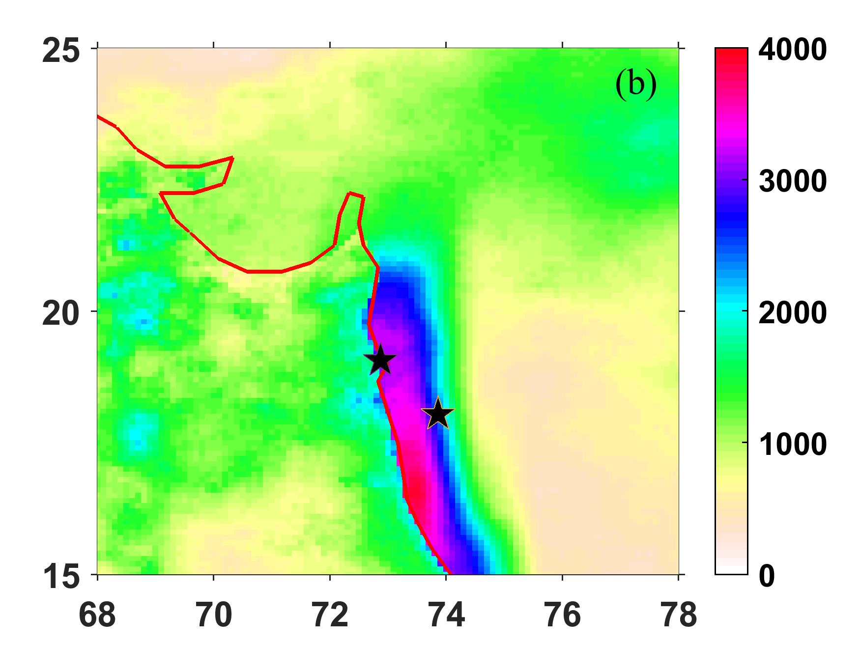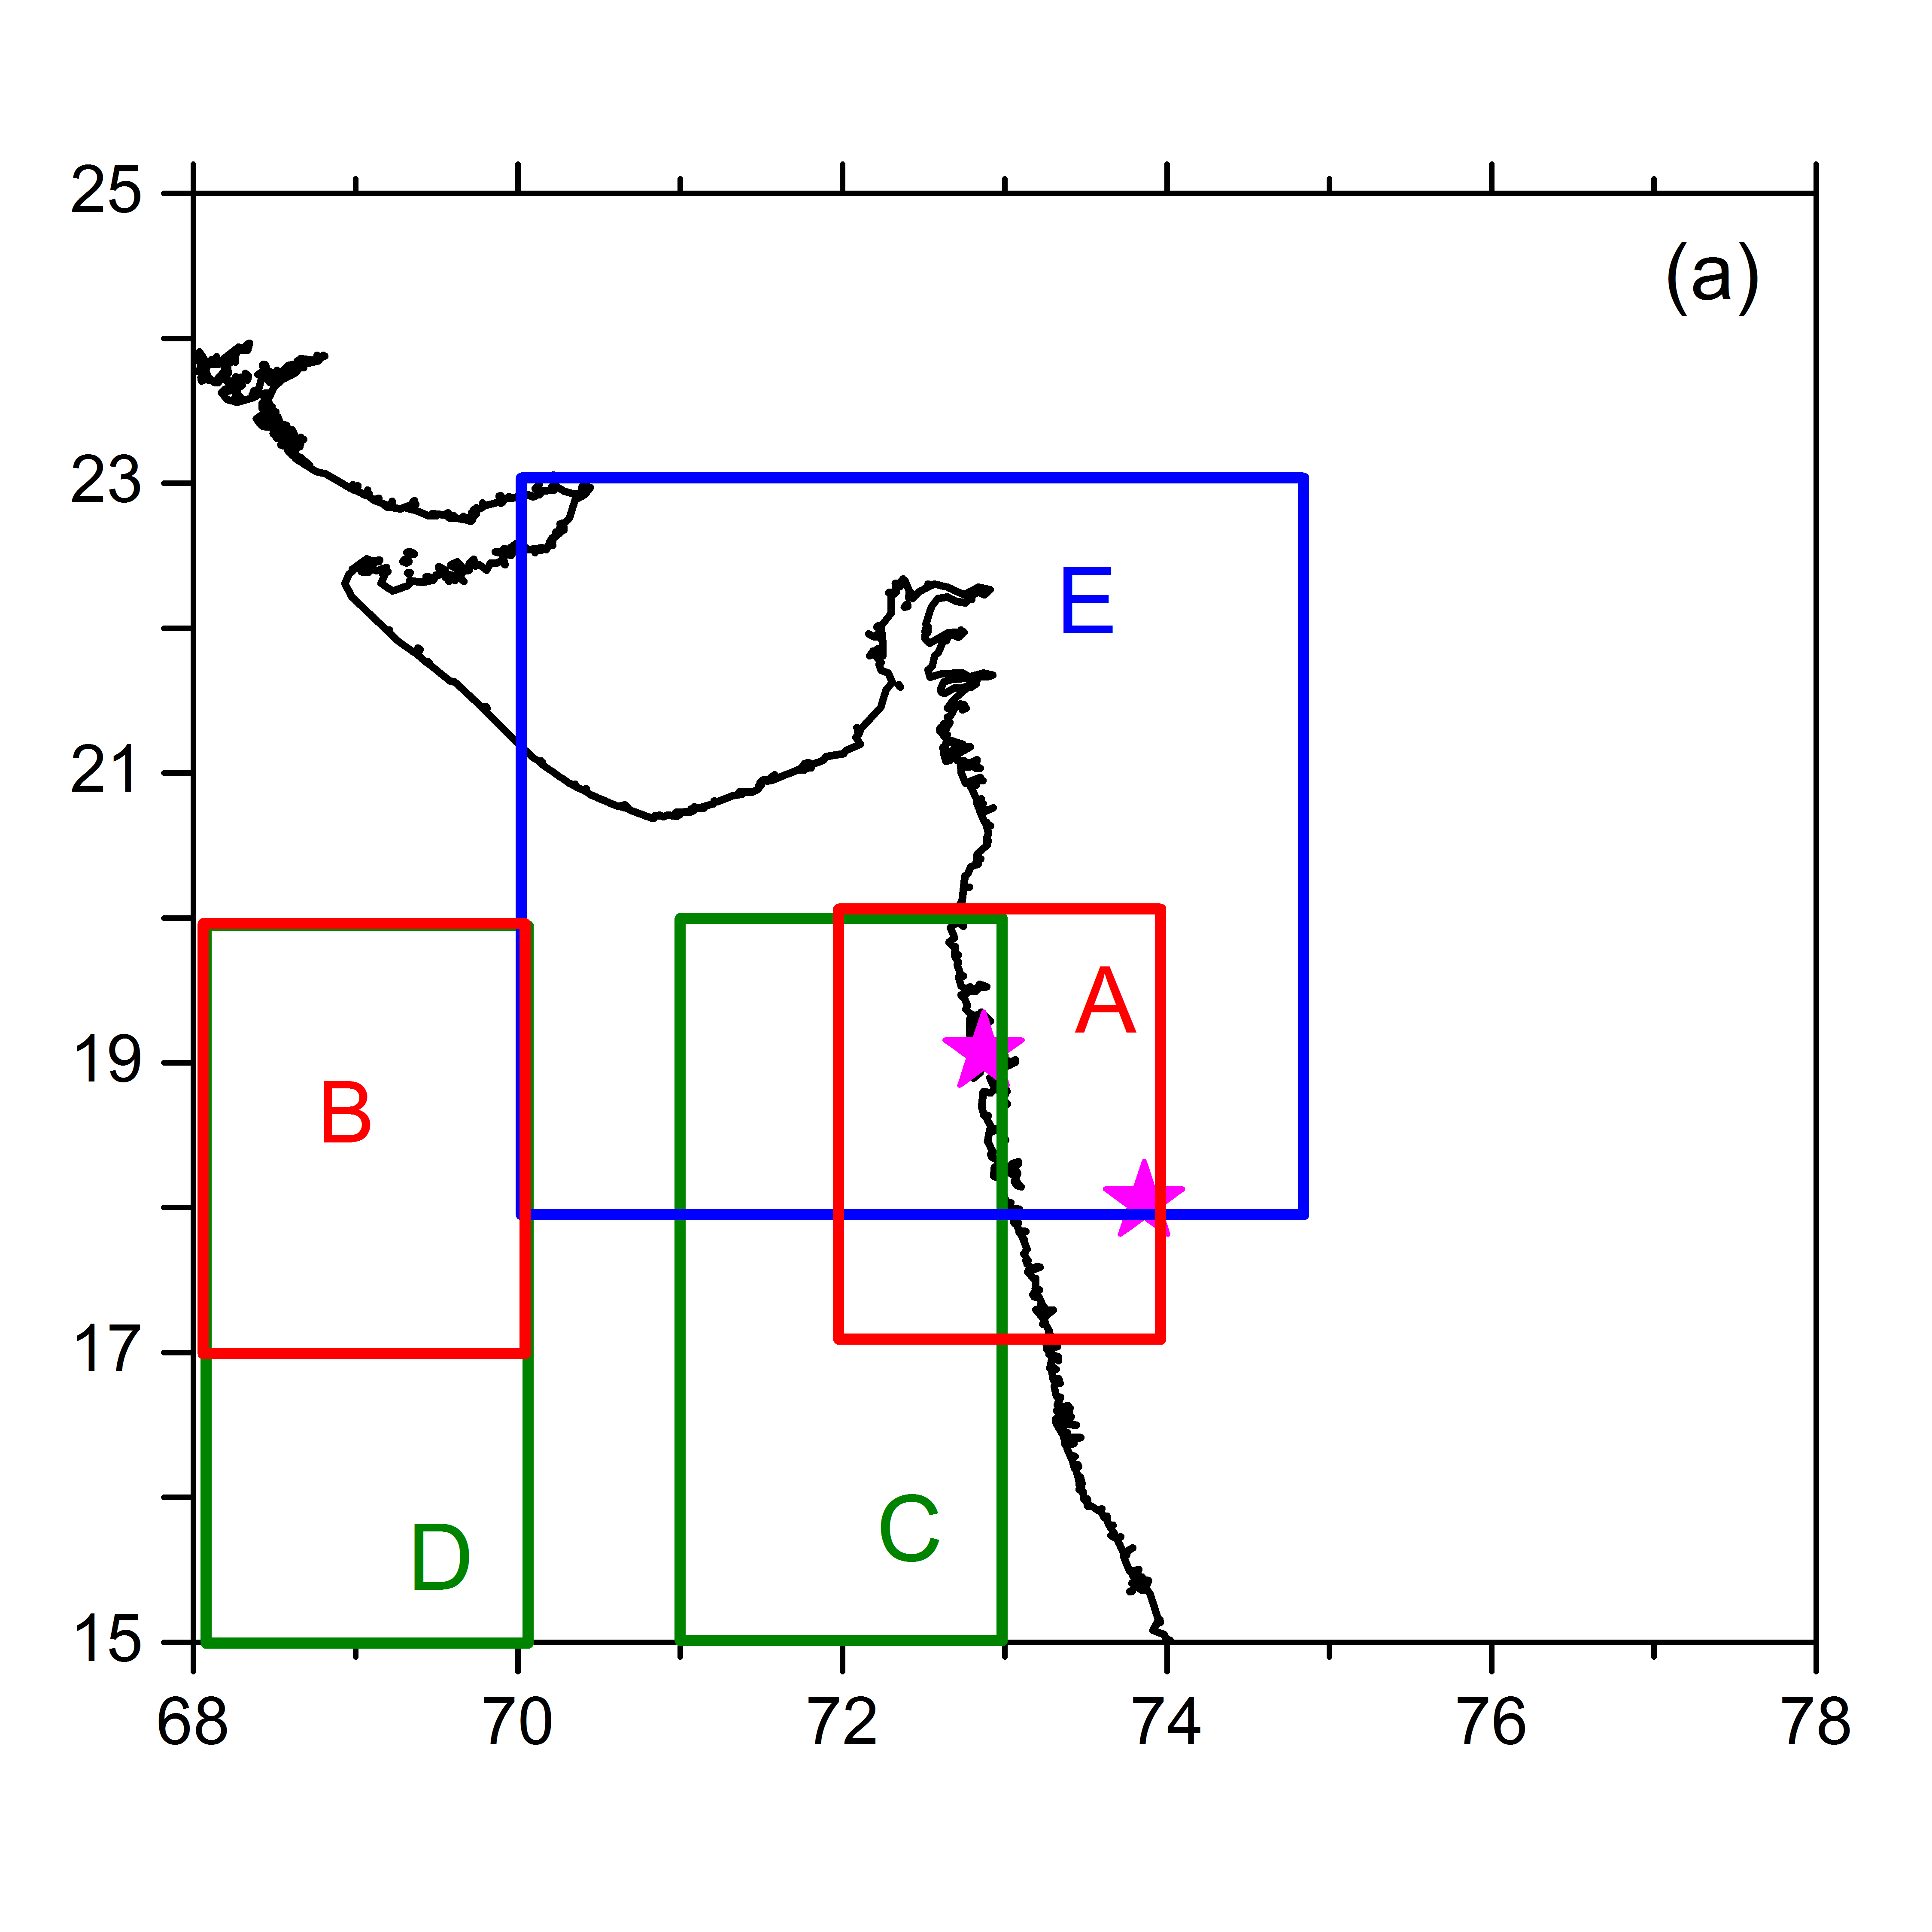



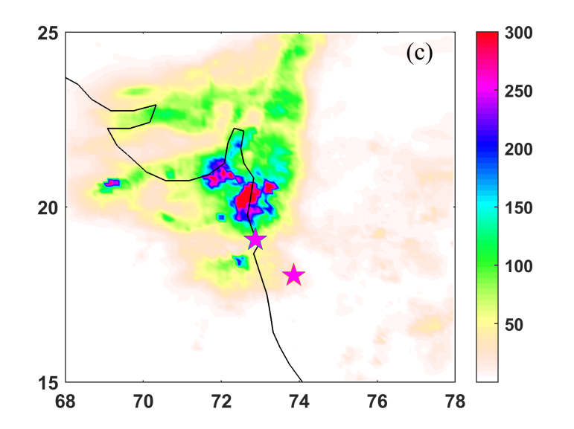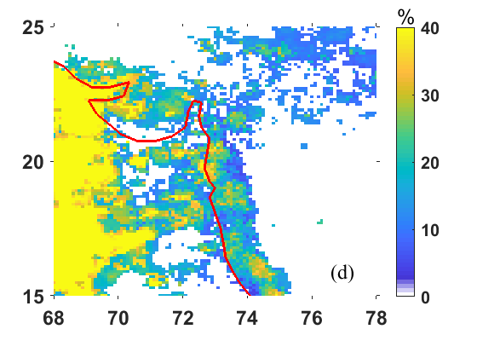

Figure-1. (a) Shows the study region and regions A, B, C, D and E are considered to explore the influence of several dynamical attributes. (b) Shows seasonal accumulation of rainfall, 2019. (c) Shows the accumulated rainfall on 28-06-2019 over the study region. (d) Heavy rainfall rain fall fraction of contributed to seasonal accumulation in 2019 over west coast region.

.

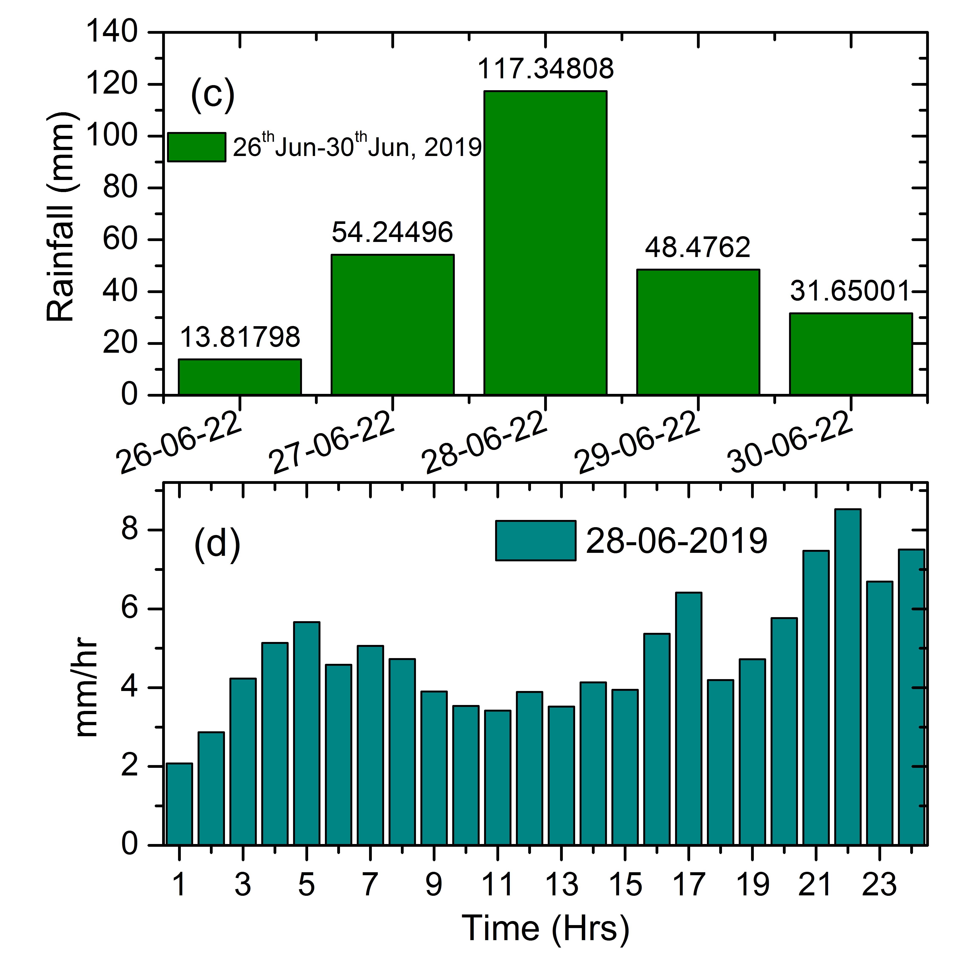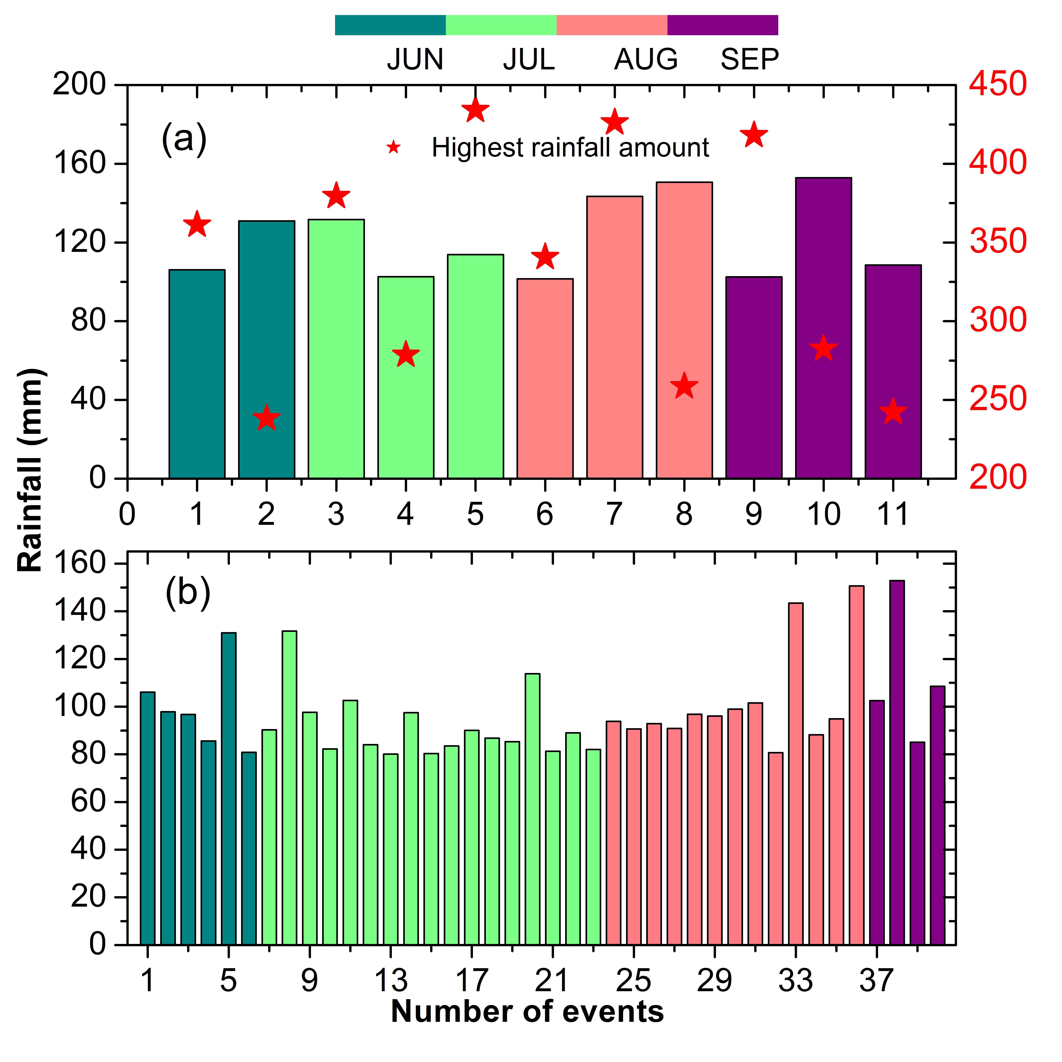

Figure-2. Seasonal distribution of Extreme precipitation Events (ERE’s) over study region during 2010-2020. Figure 2C represents daily average rainfall variability during 26th June to 30th June, 2019 over the study region. Figure 2d shows the sub daily scale variability of rainfall of an extreme event day (28-06-2019).

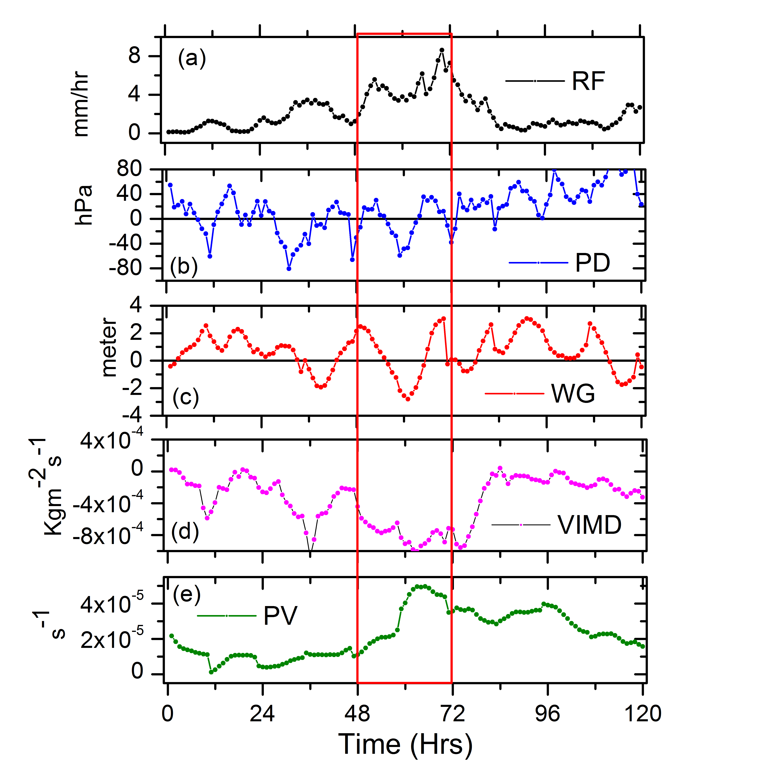

Figure 3. The temporal coherence between sub daily scale variability of rainfall intensity and its dynamical attributes such as pressure difference (PD), wind gradient effect (WG), Vertical Integrated Moisture Divergence (VIMD) and Potential Vorticity (PV) during an extreme rainfall event 26-30, Jun, 2019.

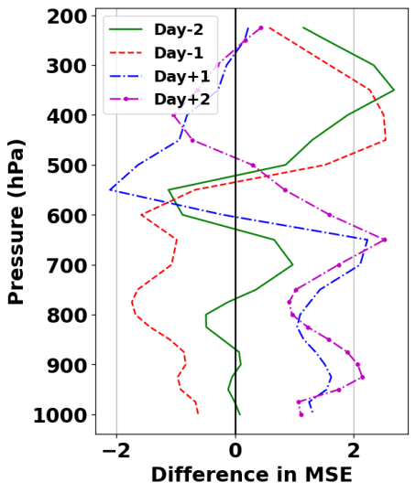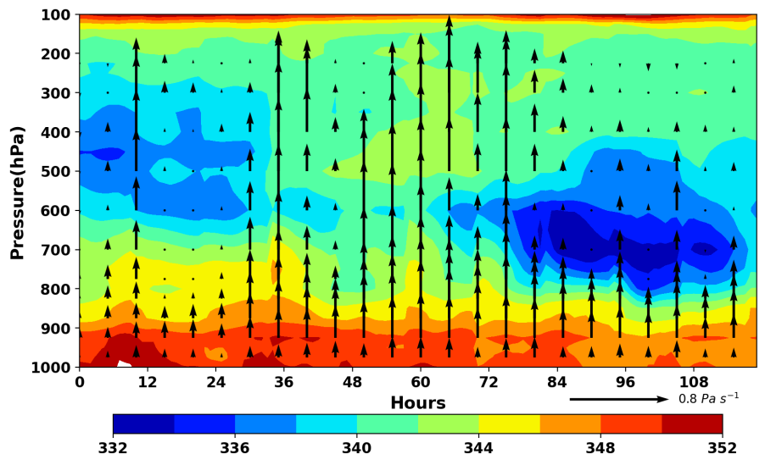

(b)

(a)

(C)

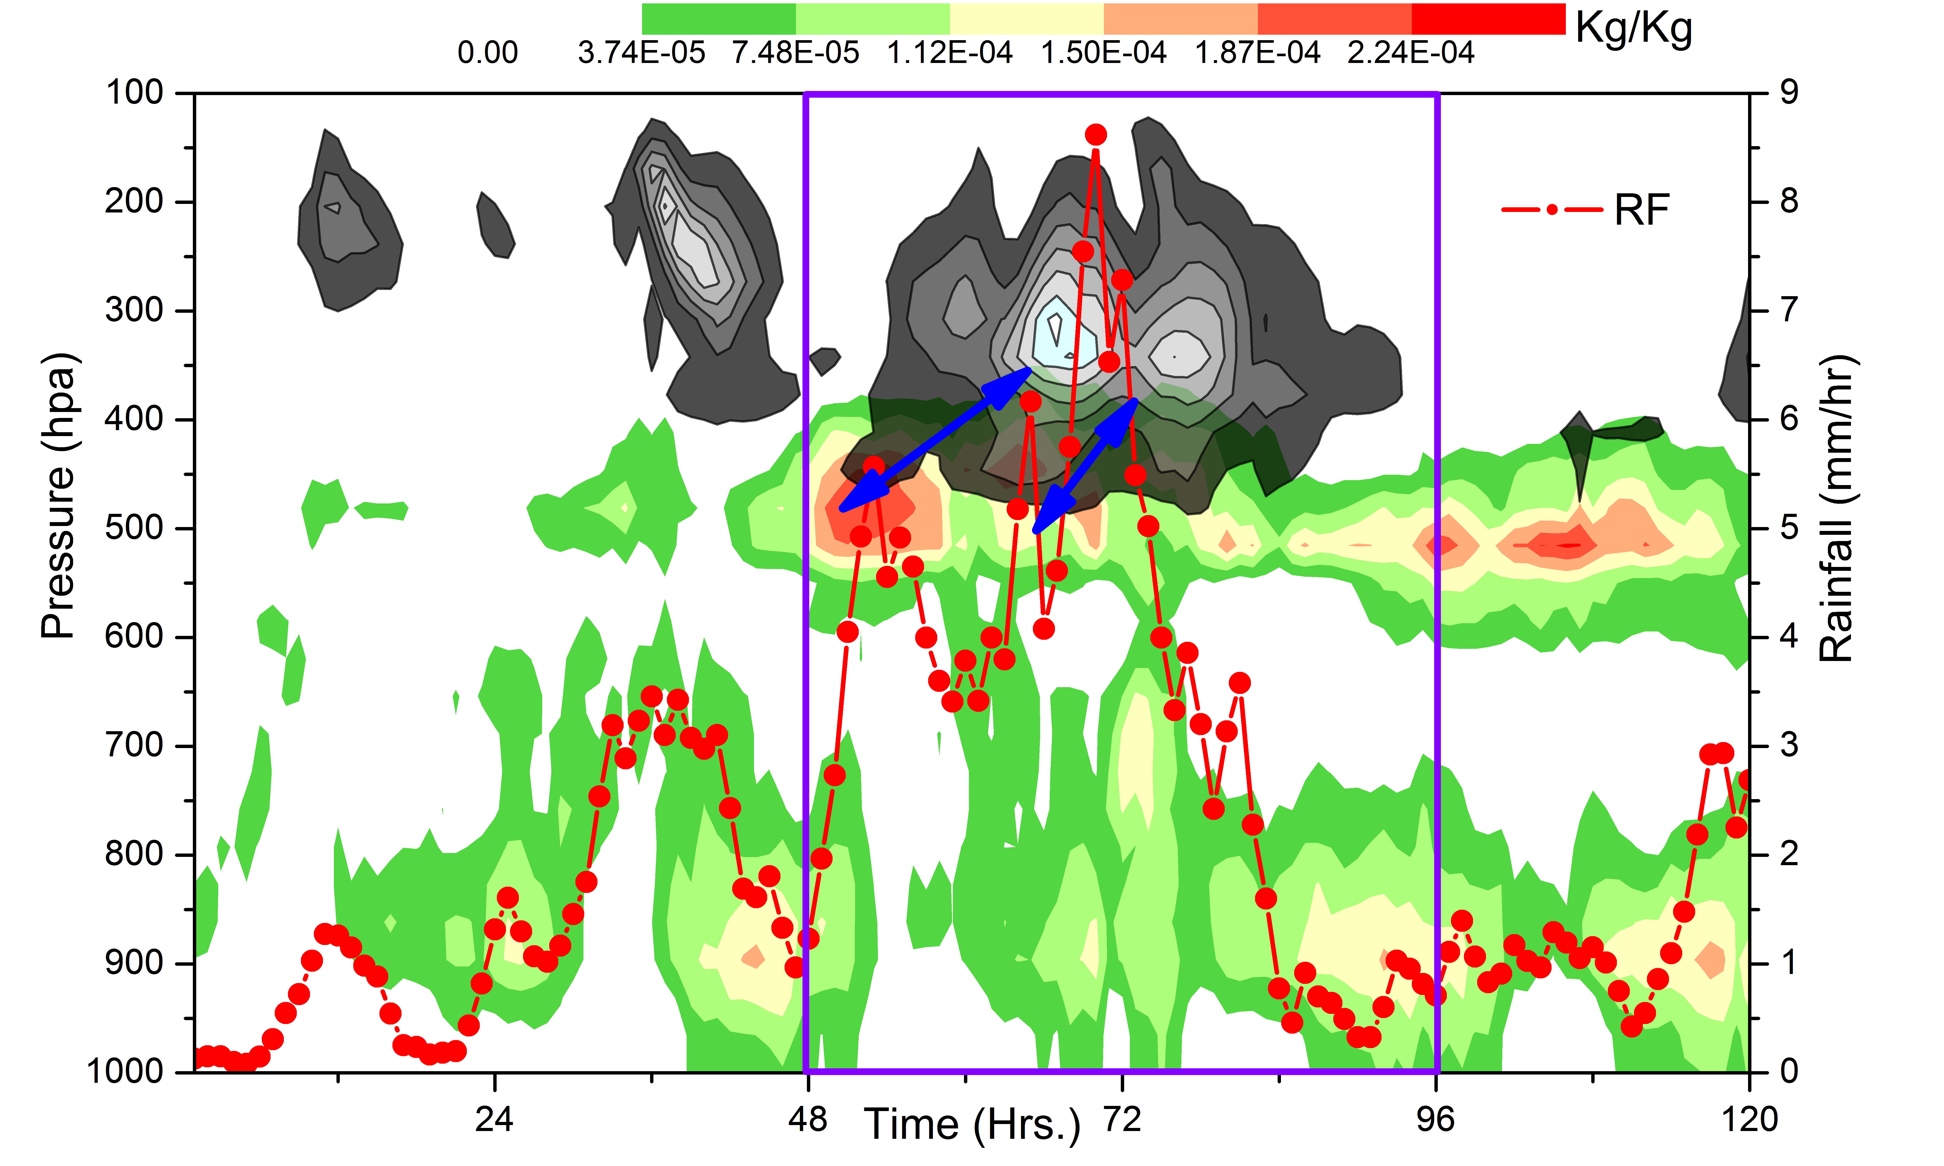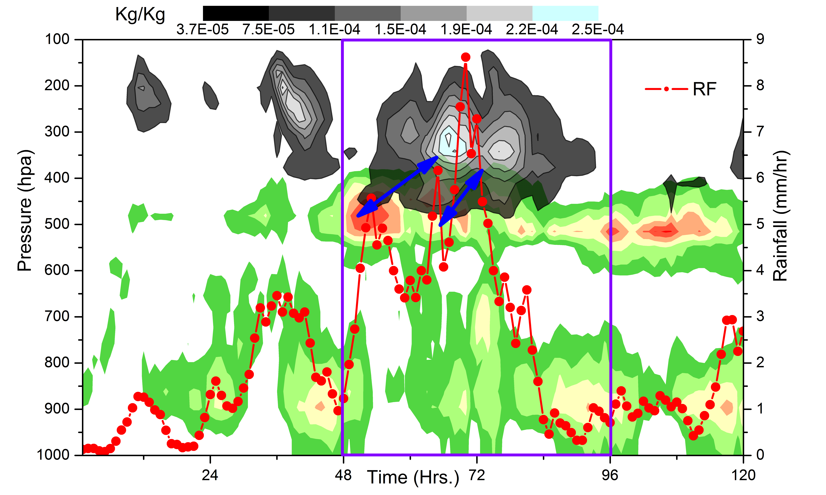

Figure 4. Two dimensional distributions of moist static energy (figure 4a) and its anomaly (figure 4b) on different phases of extreme rainfall event. In figure 4a, the up arrows represent the strength of the vertical updrafts during different phases of the extreme rainfall event. Figure 4c. Two dimensional distributions of Specific Cloud Ice Water Content (IWC) and Liquid Water Content (LWC) on different phases of extreme rainfall event on 26-30, Jun, 2019.

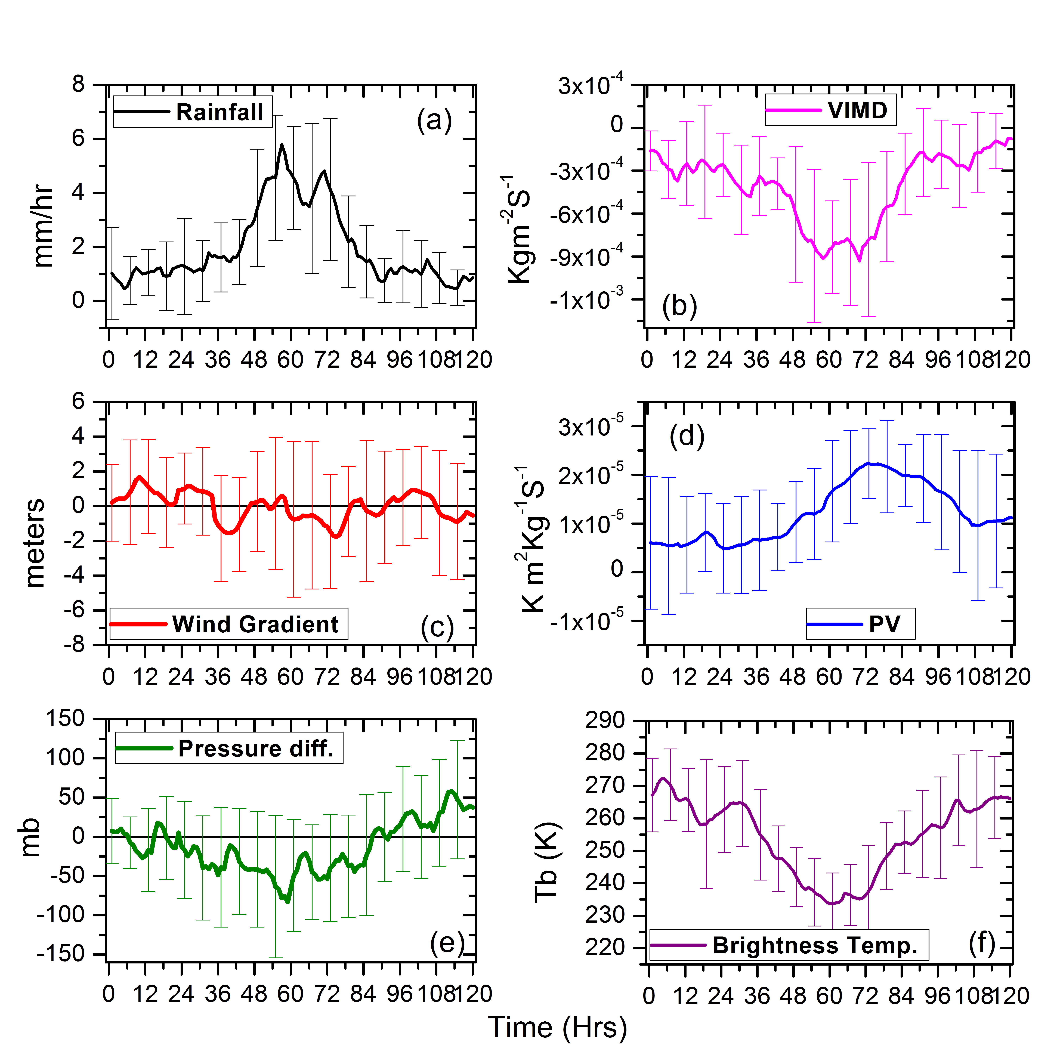

Figure-5. Composite analysis of the temporal coherence between sub daily scale variability of EREs and its possible controlling dynamical attributes.

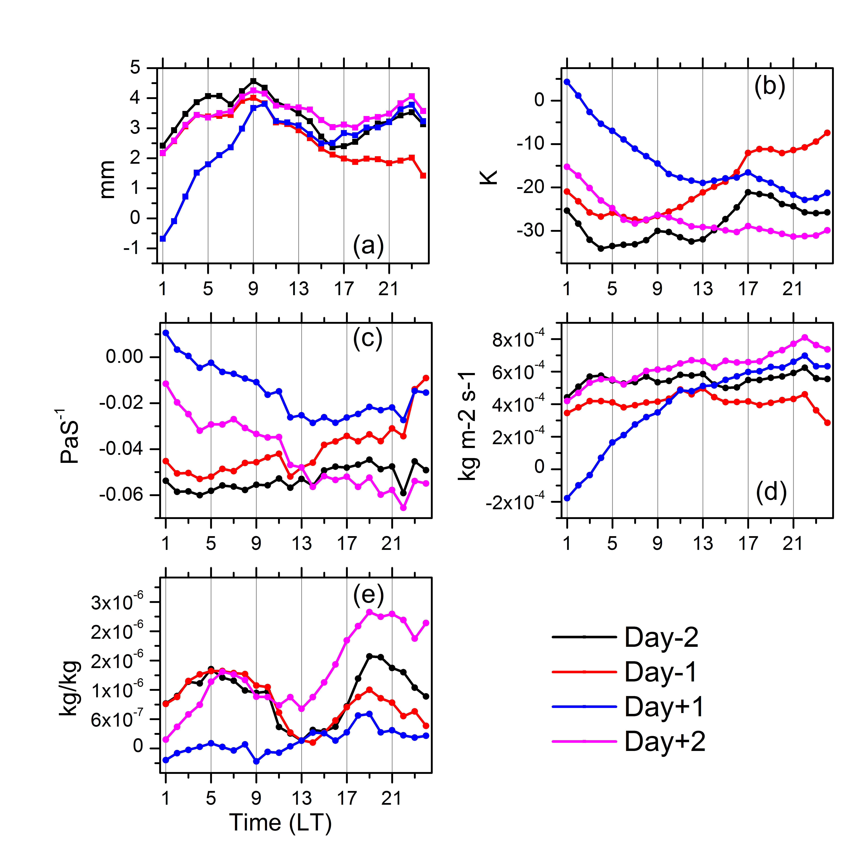

Figure 6. Sub daily scale variability of various physical attributes during different phases of the extreme event. Figure.15 a, b, c, d, and e represents rain rate, cloud top brightness temperature, pressure velocity, moisture flux and ice water content.

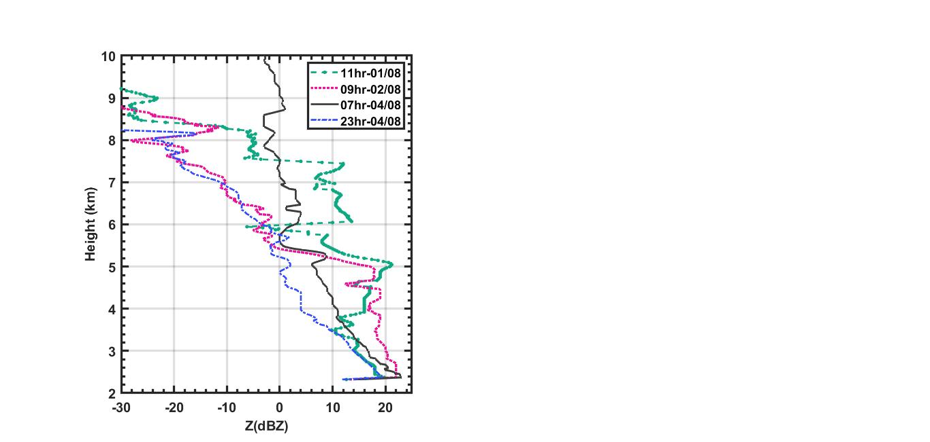

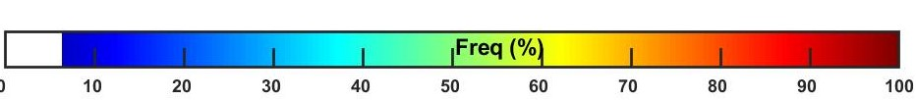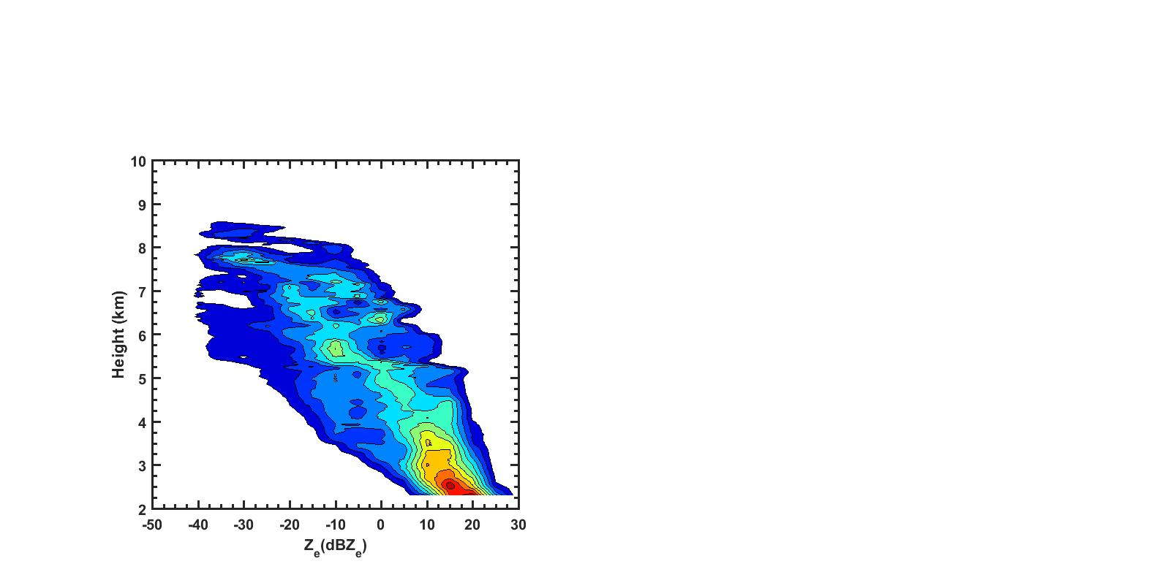

**( e )**

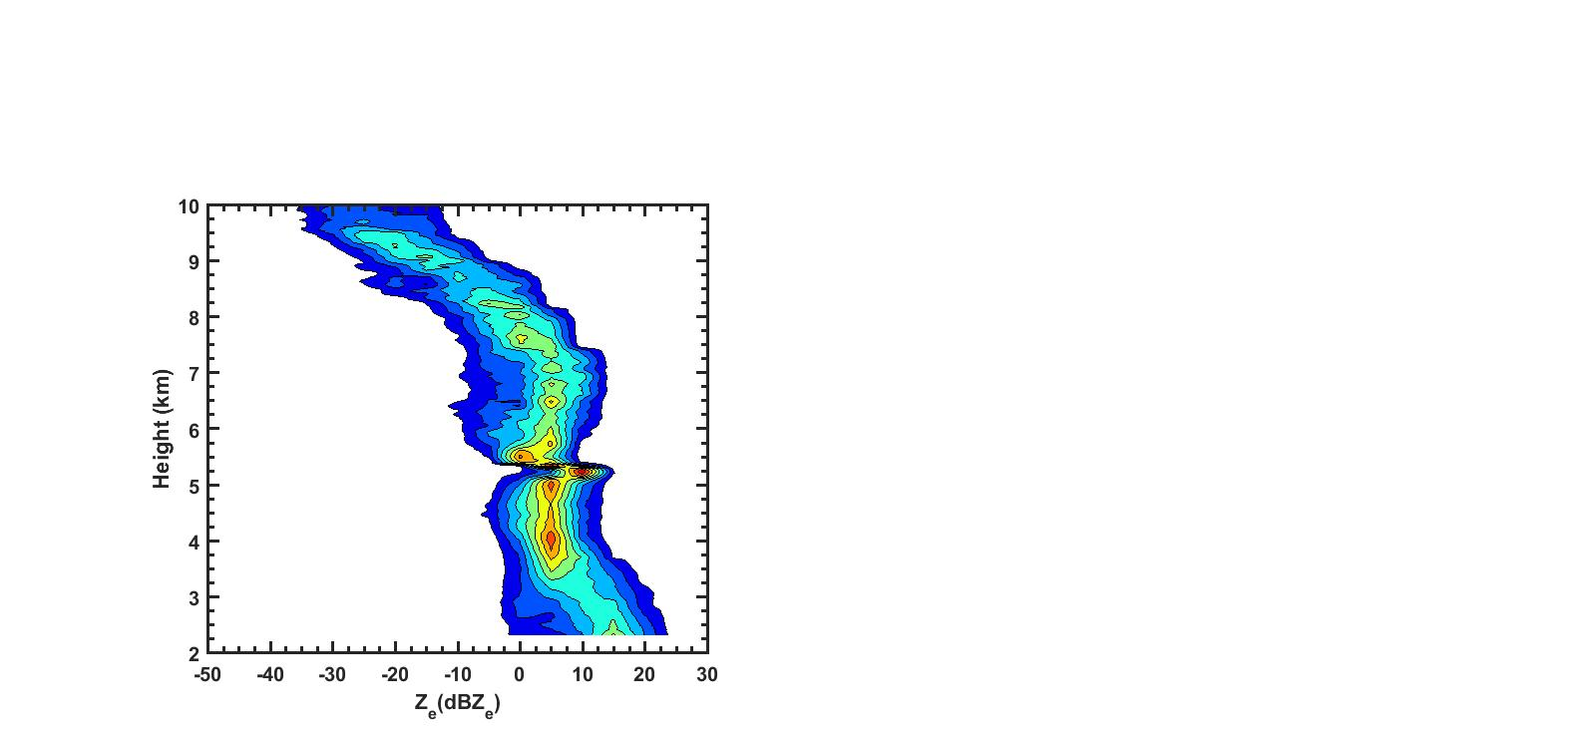

**( d )**

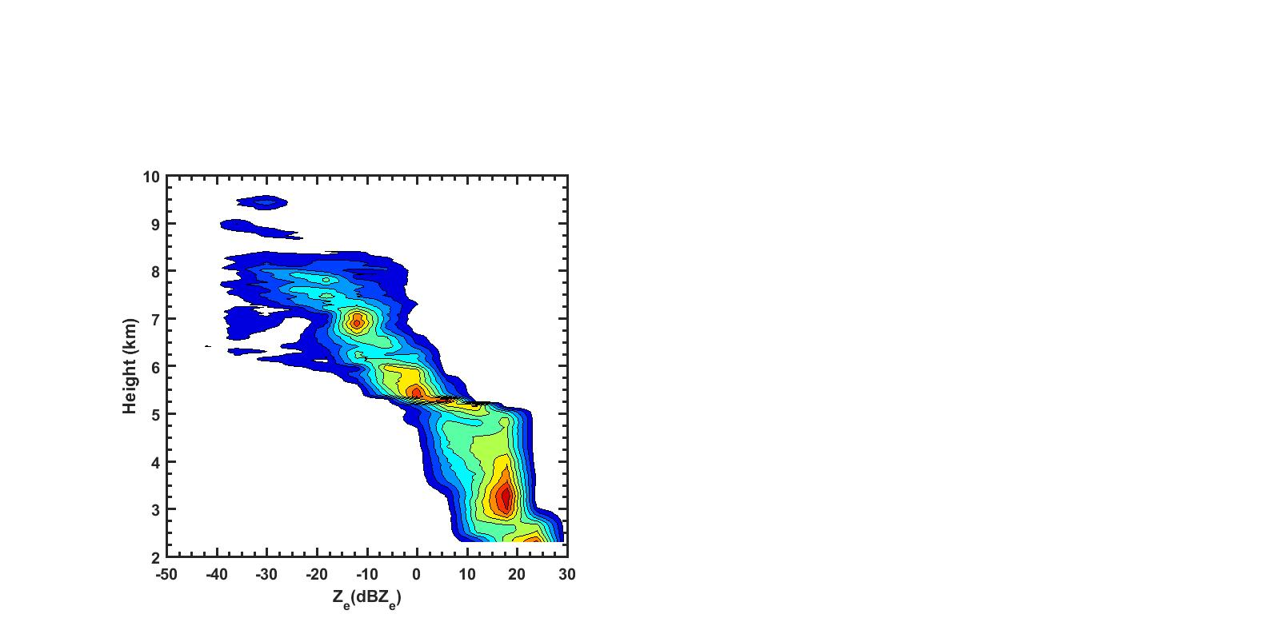

**( c )**

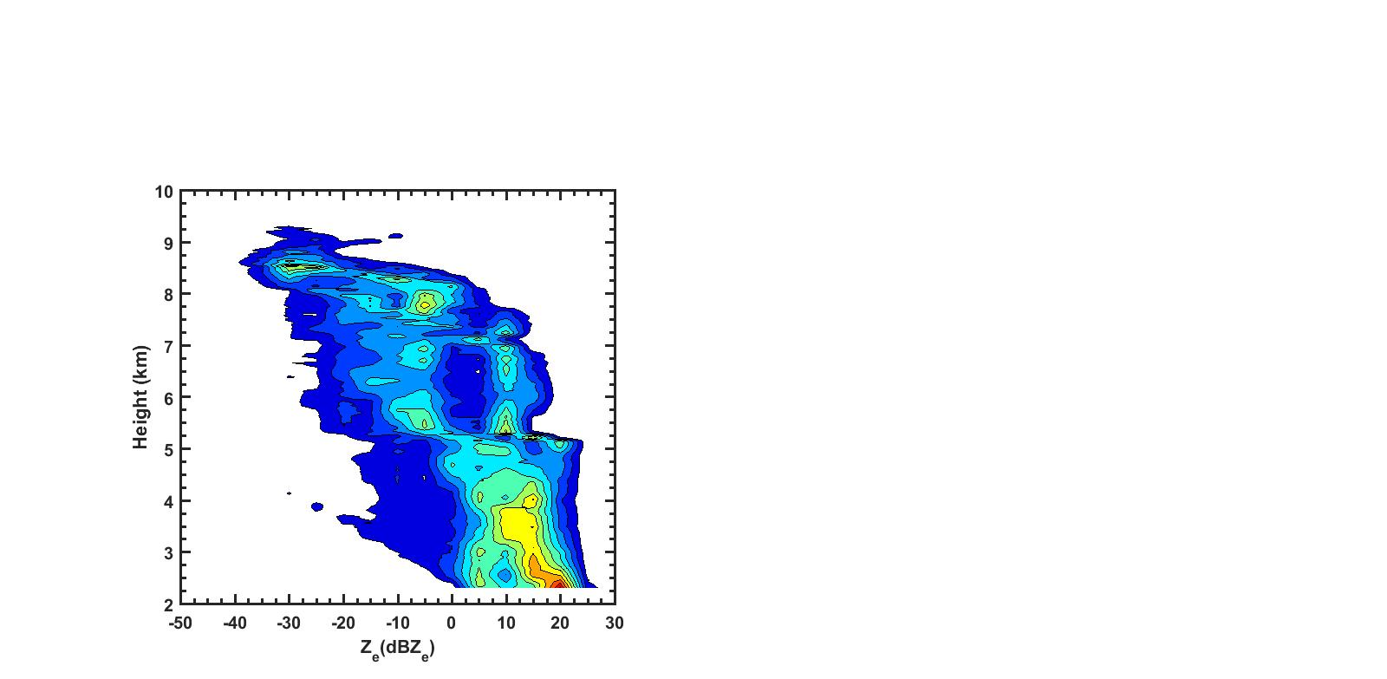

**( b )**

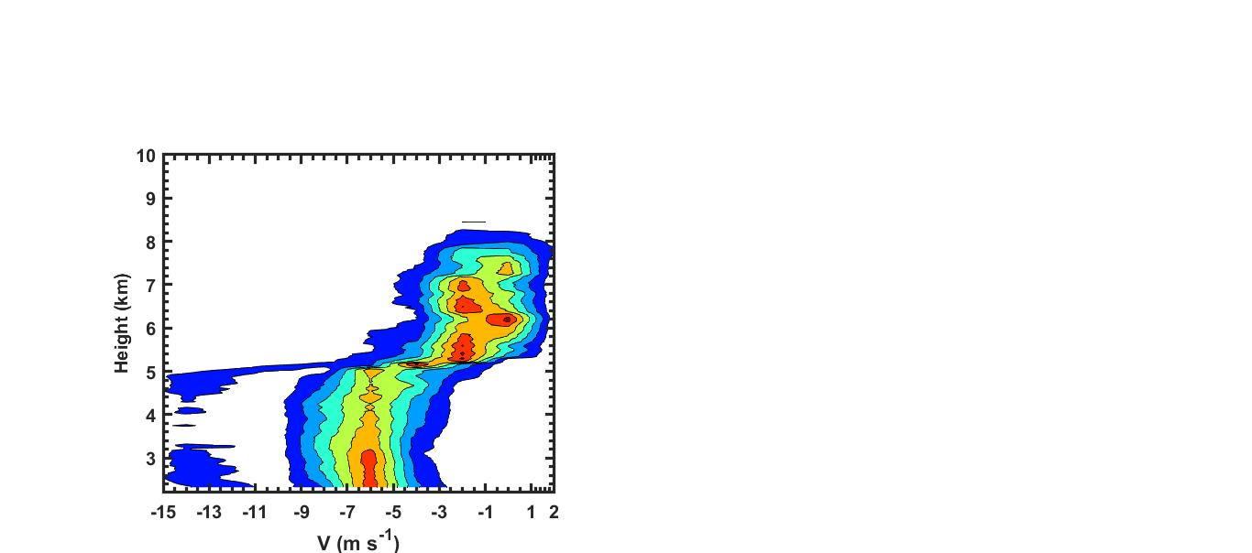

**( i )**

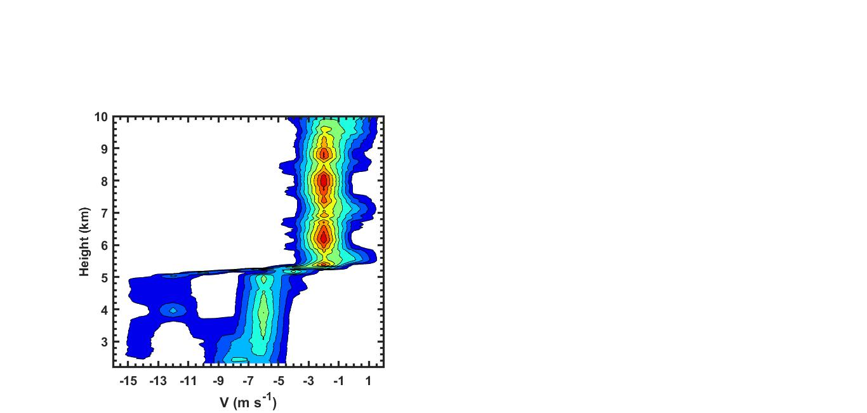

**( h )**

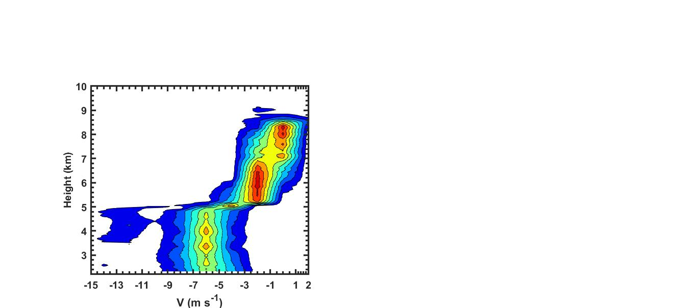

**( f )**

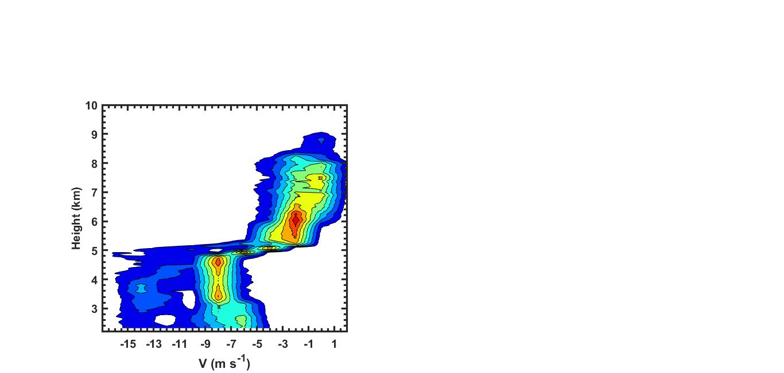

**( g )**

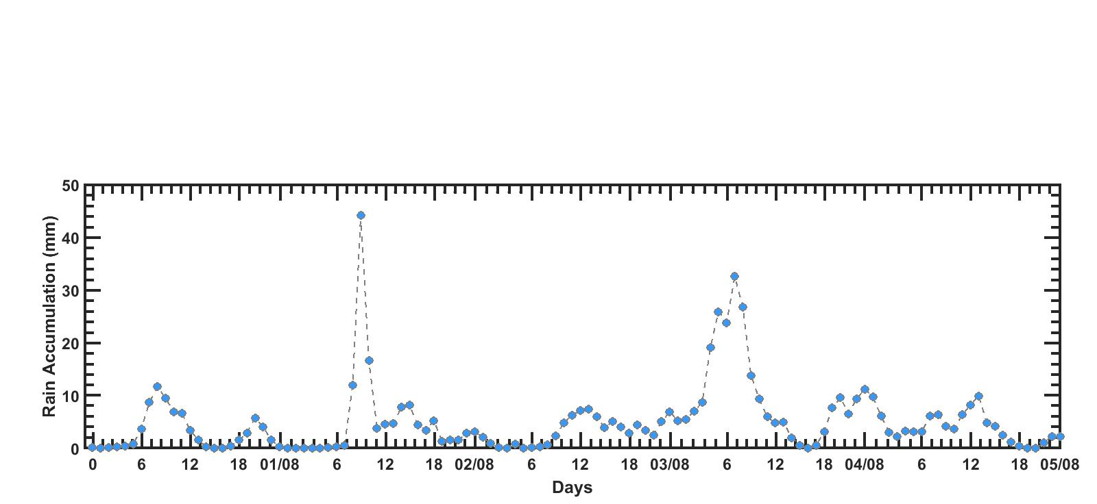

**( a )**

**Figure 7**. (a) Hourly rain accumulation from multi satellite based precipitation estimates from gauge calibration for a 5 days extreme event period from 01 Aug to 05 Aug 2019 over Mandhardev, Western Ghats. The three boxes represent the rain accumulation at the initial, medium and dissipating stage of the extreme event for which (b-d) Contoured frequency by altitude diagram (CFAD) of Ze from co-located vertical looking measurements of KaSPR is analysed.

7

**(a )**

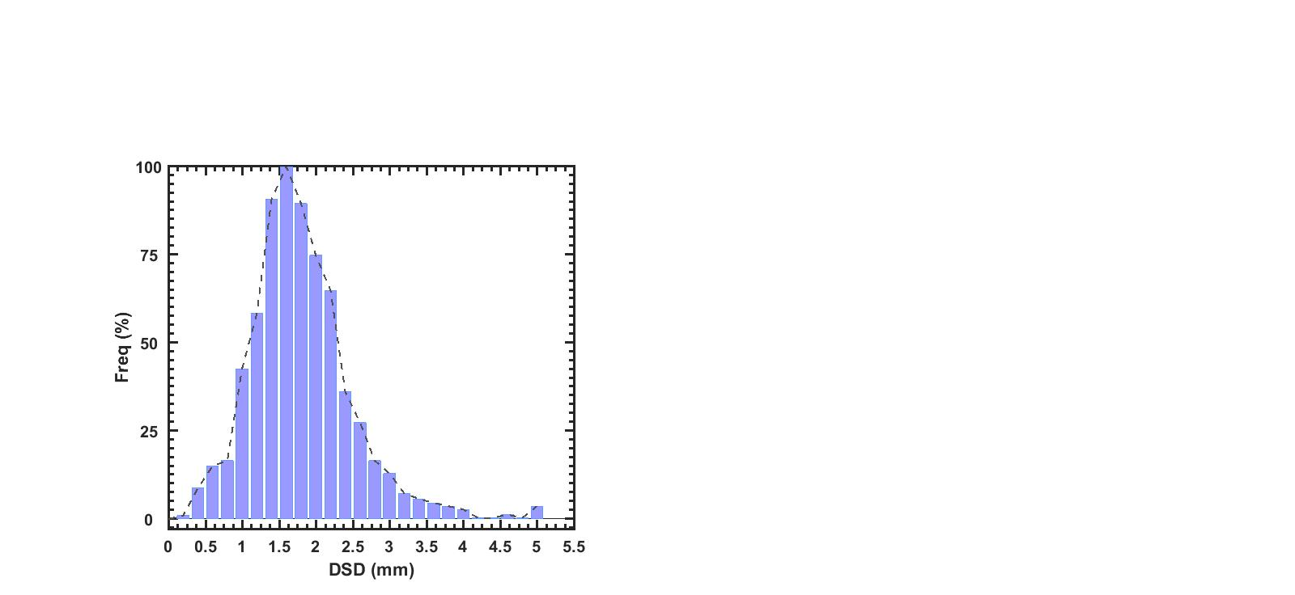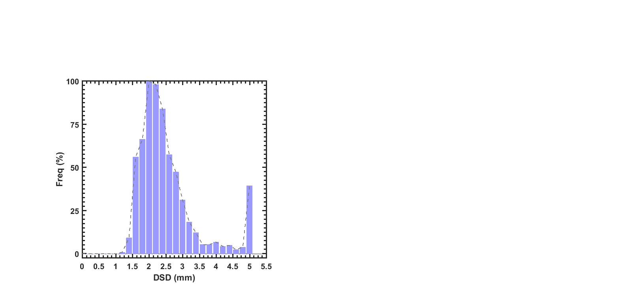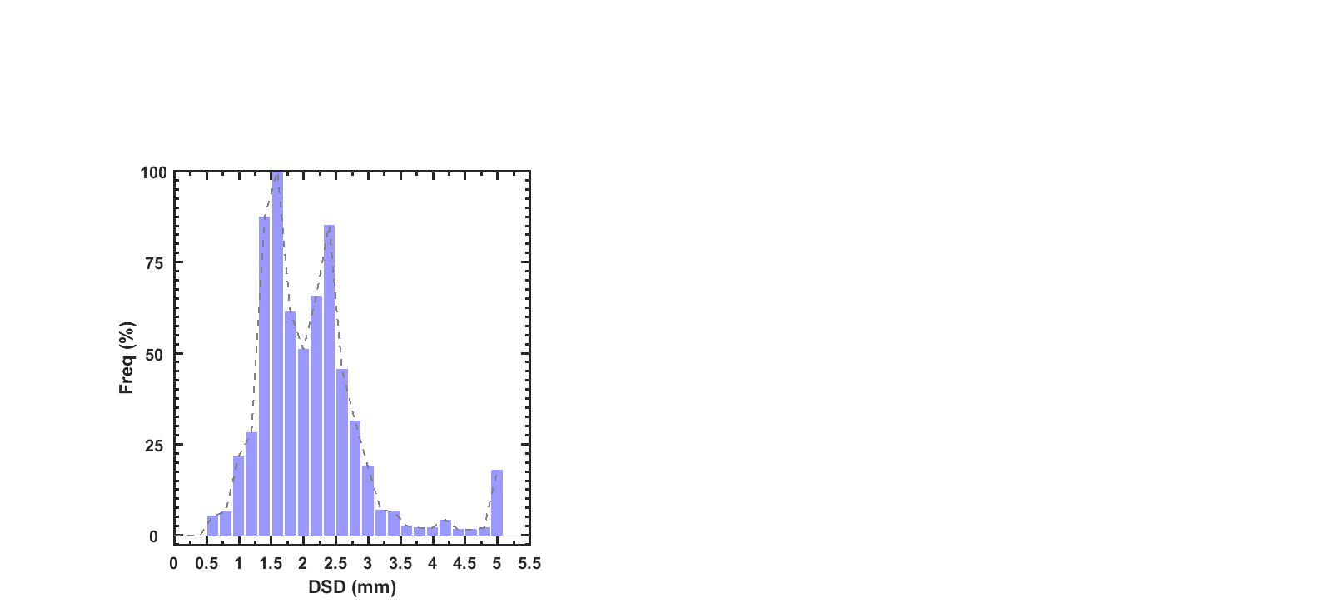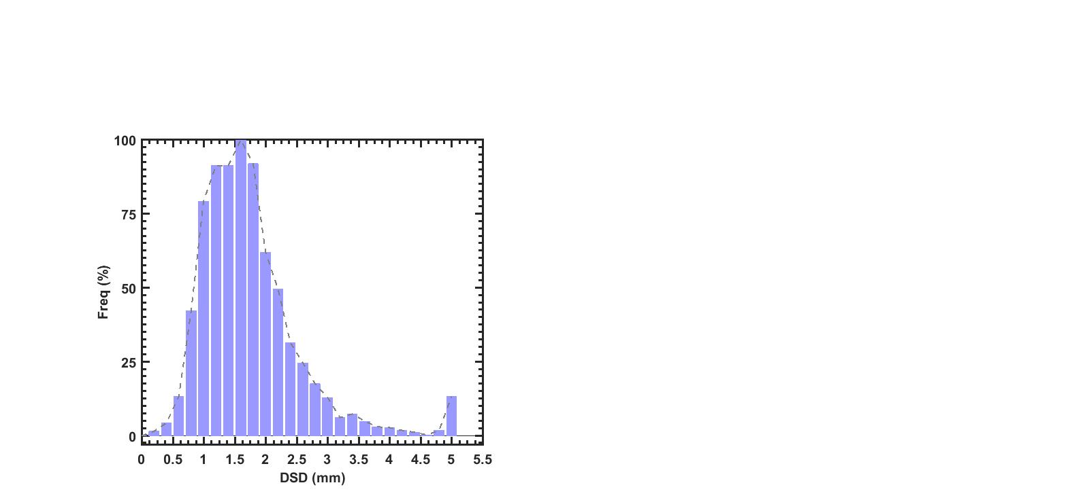

**( e )**

**( b )**

**( c )**

**( d )**

**Figure 8**. (a) Vertical profiles of mode Ze during different phases of the extreme rainfall event over study region. (b-e) estimated DSD from KaSPR velocity observations at the lowest range bin (2.2 km) using Gunn and Kinzer’s (1949) formula at the initial, medium and dissipating stage of the 5 days extreme event from 01 Aug to 05 Aug 2019.

References:

**Author contribution statement:**

S.K. and M.C.R. conceived and designed the study. S.K., S.P., and M.N. analysed the results. All the authors have contributed in writing the paper.